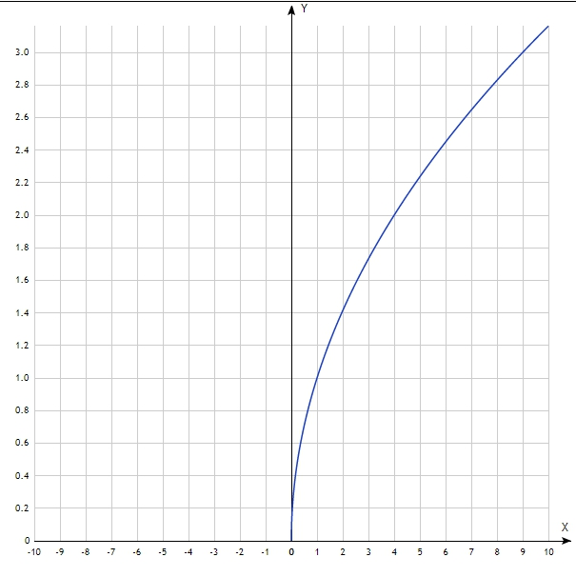
-2 | -
-1 | -
0 | 0
1 | 1
2 | 1.41
3 | 1.73
4 | 2
5 | 2.24
6 | 2.45
7 | 2.65
8 | 2.83
9 | 3
10 | 3.16

