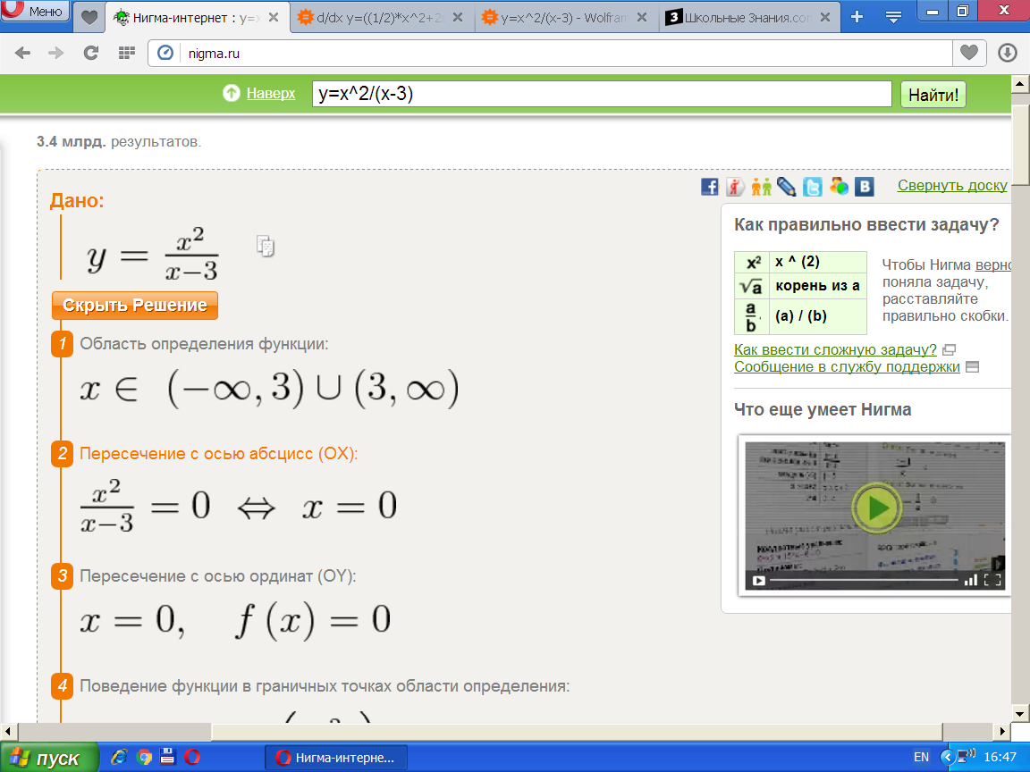

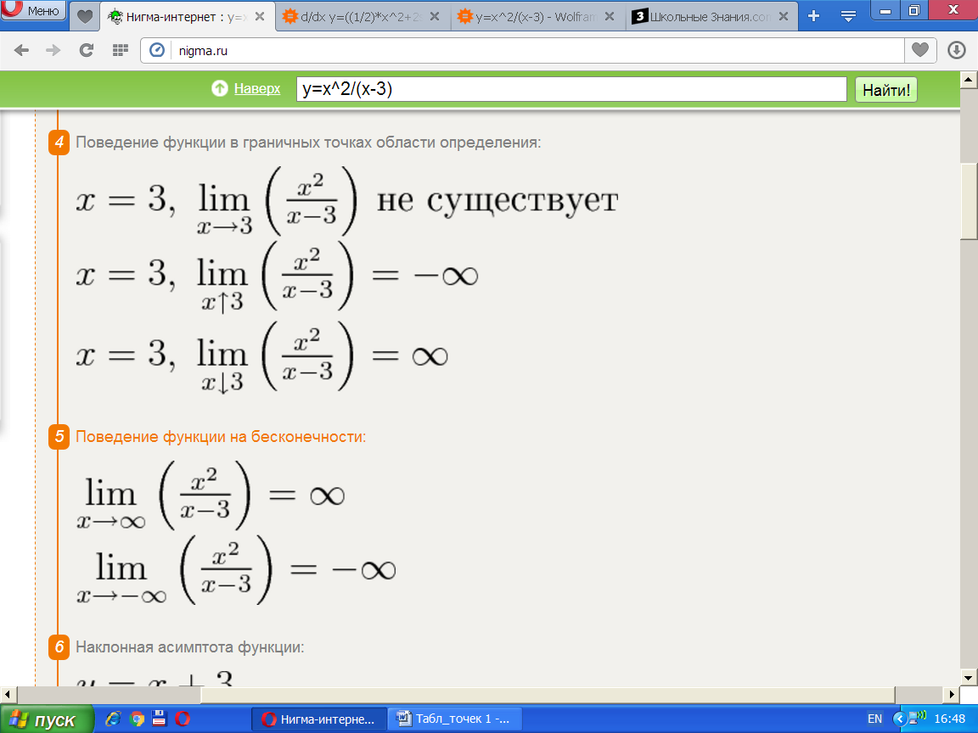

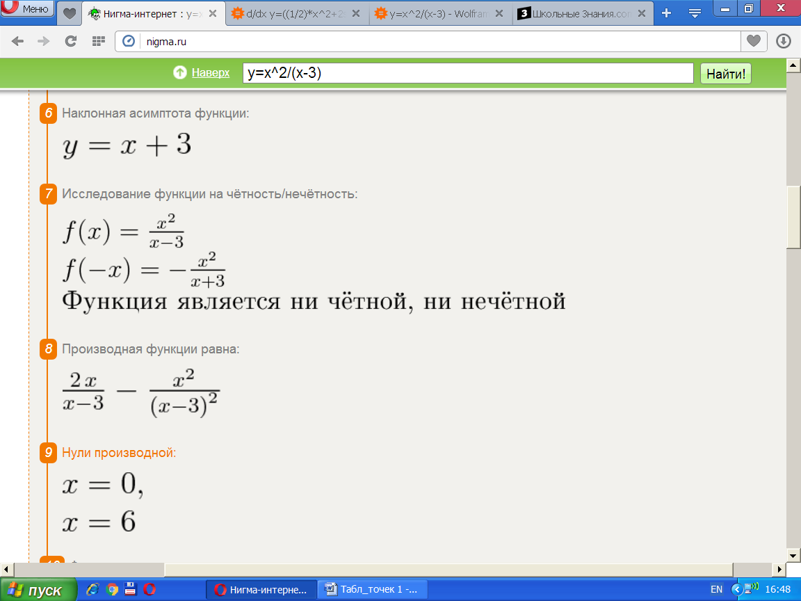

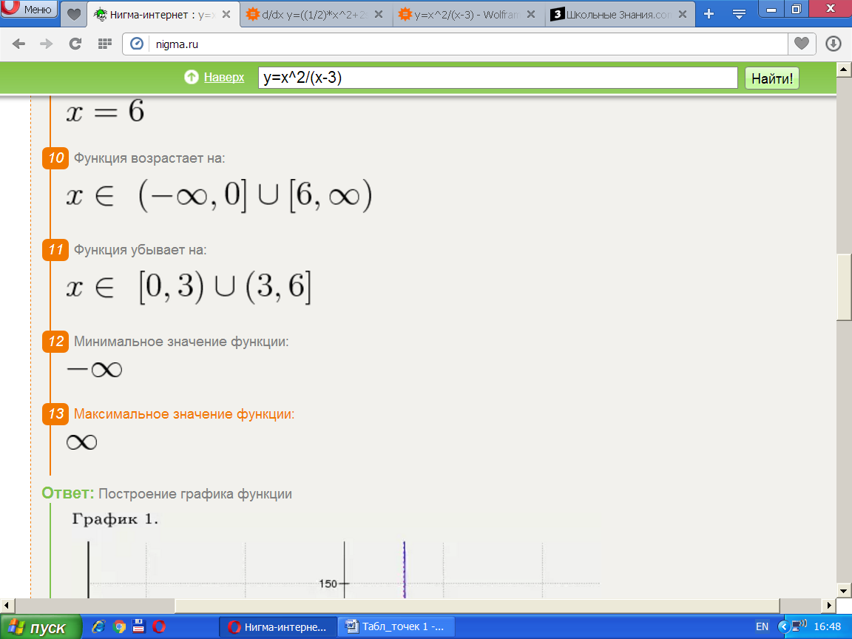

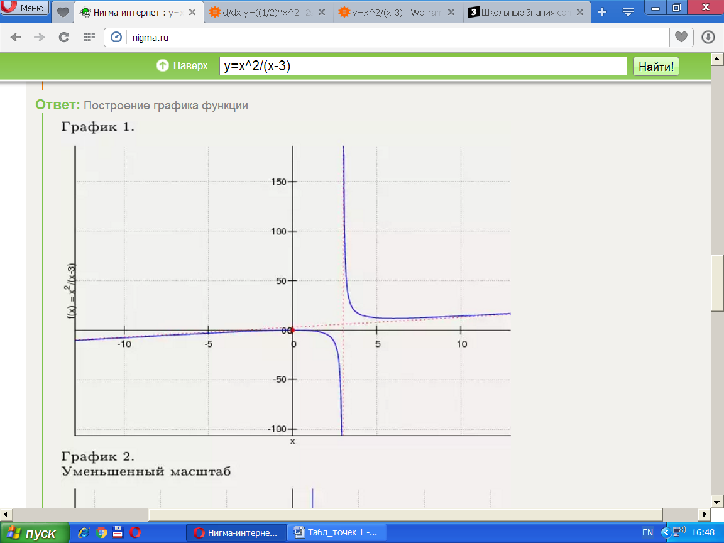

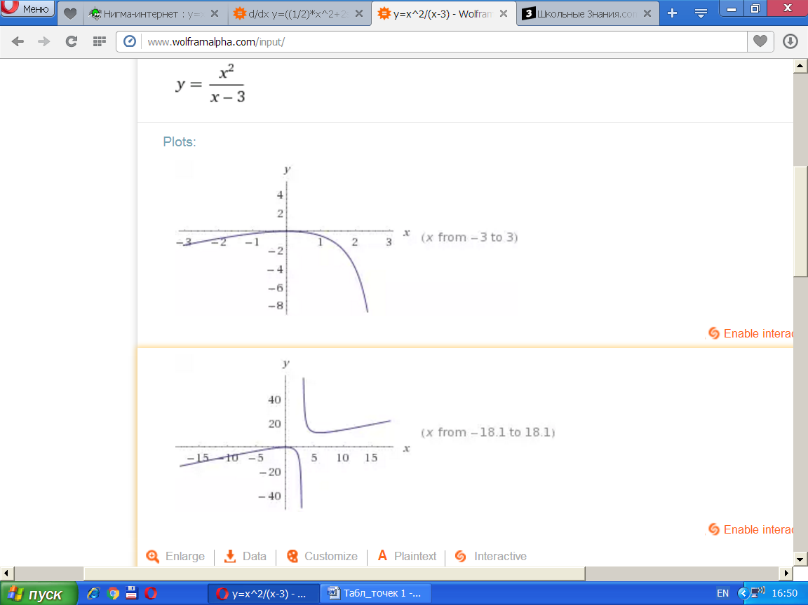

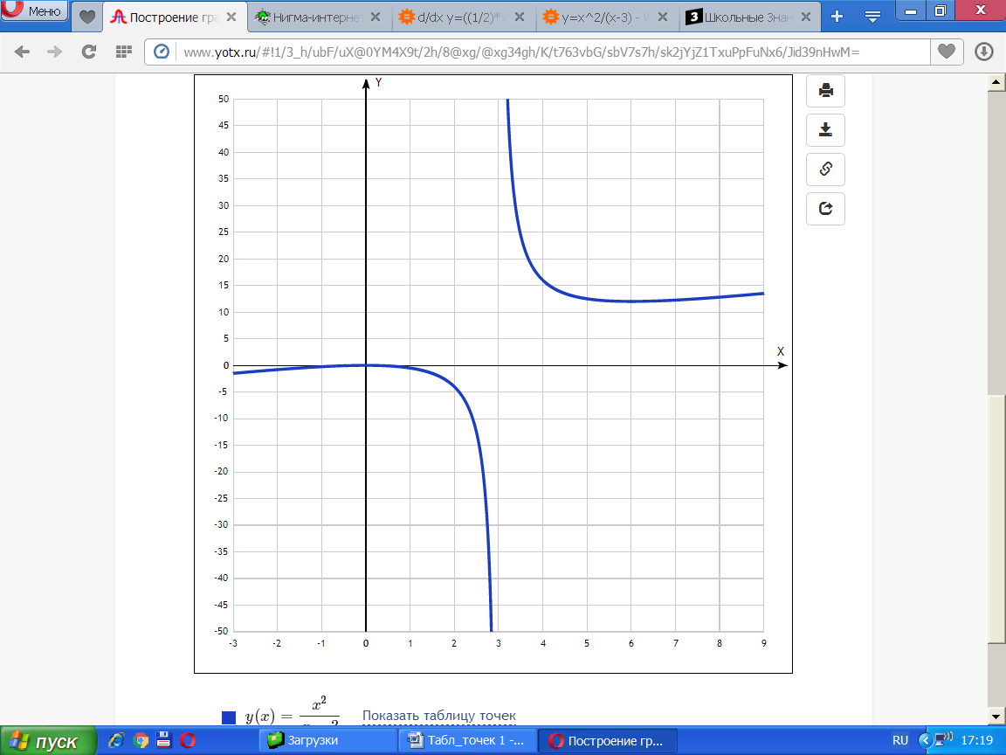

y(x)=x2/(x−3) [Таблица точек](javascript:void(0);)

|  |  |
| --- | --- |
| **x** | **y** |
| -3 | -1.5 |
| -2 | -0.8 |
| -1 | -0.2 |
| 0 | 0 |
| 1 | -0.5 |
| 2 | -4 |
| 3 | - |
| 4 | 16 |
| 5 | 12.5 |
| 6 | 12 |
| 7 | 12.3 |
| 8 | 12.8 |
| 9 | 13.5 |