Make up a dialogue: your British friend is talking to you at your birthday.
Pupil 1
You are a Russian host
Remember to thank your English friend for the present.
Express your admiration
Pupil 2
You are the English friend.
You begin the conversation.
Remember to give a gift and say your wishes.
Объем- по 5 фраз от каждого (см. стр. 59-60). Прислать один файл от двоих (от руки или в Word). Если составляете в одиночку- объем тот же. Задание выполнить сегодня в течение дня и прикрепить в ячейку к домашнему заданию. Если задание выполняли двое- в самой работе указать фамилии.
Образцы (отсюда можно брать фразы, но диалог списать не получится)
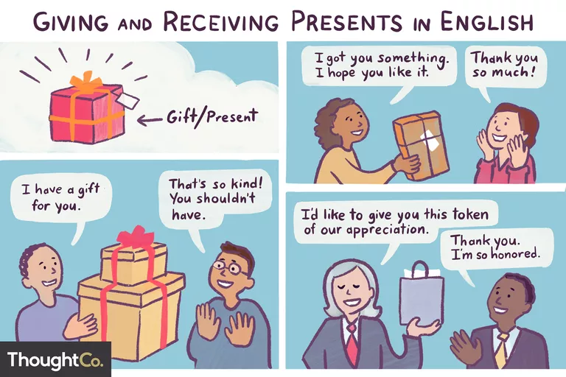

Phrases for Giving Gifts

Informal Situations
Here are some common informal phrases you can use when giving a gift to a close friend, a family member, or a loved one:
- I got you something. I hope you like it.
- Look what I have for you!
- I thought you might like this for...
- Happy Birthday! [Happy Anniversary!] Here's a little gift/present for you.
- [Handing present to someone] Enjoy!
- It's only something small, but I hope you like it.
- Here's a little present for you.
- Guess what I bought you!

Formal Situations
These are a few common phrases for gift-giving in formal settings, such as a wedding or a business dinner:
- [Name], I'd like to give you this present/gift.
- [Name], This is a present that I/we/staff got you.
- I'd like to present you with this...(very formal, used when giving an award or special present)
- In the name of [xyz], I'd like to give you this present. (also very formal)
- Here is a token of our appreciation.

Phrases for Receiving Presents
- Thank you so much!
- That's so kind!
- You shouldn't have!
- Thank you! It's beautiful.
- I love it! I'll put it on/hang it up/... immediately.
- That is so thoughtful of you. It matches my...perfectly!
- How did you know I've always wanted a...to go with my...?
- Thank you. I really needed a...
- Fantastic! I've been thinking about getting a...
- This is exactly what I needed. Now, I can...
- How kind of you! I've always wanted to see...in concert/at the movies/at an exhibition.
- Wow! This is a dream come true! Tickets for...
- Thank you so much! I've hoped/wanted to travel to...for a long time.

Образец диалога Informal
- Friend 1: Tammy, I need to talk to you for a moment.
- Friend 2: Anna, hi! It's good to see you.
- Friend 1: I got you something. I hope you like it.
- Friend 2: I'm sure I will. Let me open it!
- Friend 1: It's only something small.
- Friend 2: Come on. Thank you so much!
- Friend 1: Well, what do you think?
- Friend 2: I love it! It matches my sweater!
- Friend 1: I know. That's why I bought it.
- Friend 2: How did you know I've always wanted a broach to go with this sweater?
- Friend 1: I'm glad you like it.
- Friend 2: Like it? I love it!

