ZERO

If + Present Simple, Present Simple

|  |
| --- |
| *Истина 100%,*  *Чаще всего про природу* |

If it rains, there are puddles

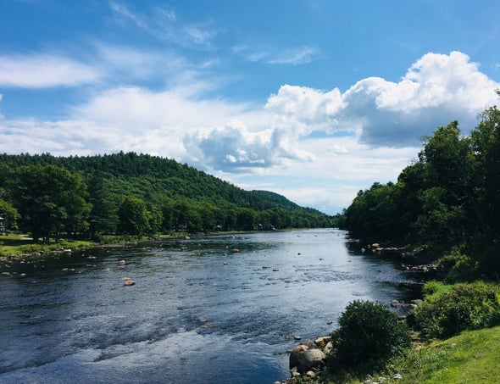

FIRST

If + Present Simple, will + infinitive

|  |
| --- |
| *Связь первого и второго предложений = реальность*  *Причинно-следственная связь* |

If I study hard, I will pass my exams



SECOND

If + Past Simple, would + infinitive

|  |
| --- |
| *Нереальное прошлое, которое может произойти*  *«Если бы, да кабы»* |

If I were a president, I would ban online learning



THIRD

If + Past Perfect, would have + Verb in 3rd form

|  |
| --- |
| *Сожаление в прошлом, которое не вернуть*  *«Ах, если бы…»* |

If I had studied harder, I wouldn’t have failed my exams

