https://znanija.com/task/23790583 $y=2x^{3}+3x^{2}-2$
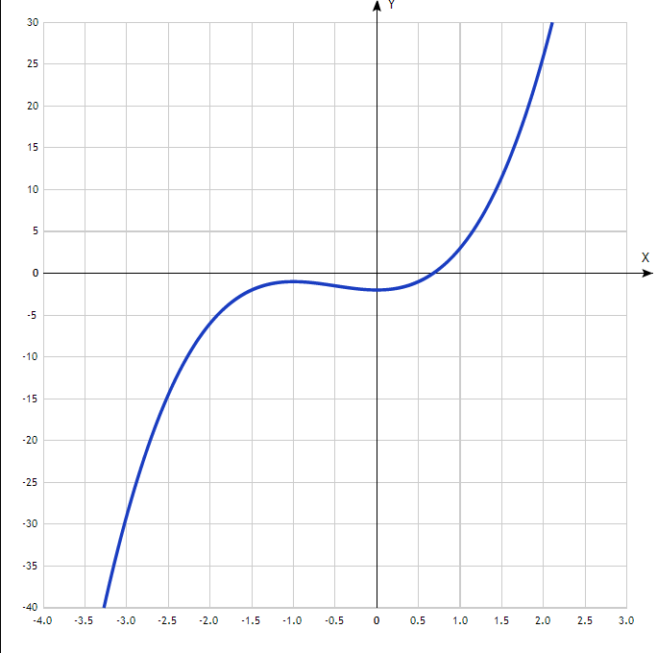
Таблица точек

x | y
-4.0 | -82
-3.5 | -51
-3.0 | -29
-2.5 | -14.5
-2.0 | -6
-1.5 | -2
-1.0 | -1
-0.5 | -1.5
0 | -2
0.5 | -1
1.0 | 3
1.5 | 11.5
2.0 | 26
2.5 | 48
3.0 | 79

