$$y={2x}^{3}-9x²$$

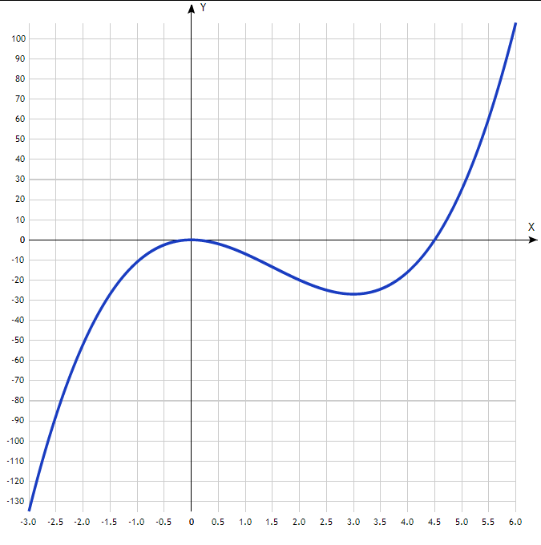
Таблица точек

x | y
-3.0 | -135
-2.5 | -87.5
-2.0 | -52
-1.5 | -27
-1.0 | -11
-0.5 | -2.5
0 | 0
0.5 | -2
1.0 | -7
1.5 | -13.5
2.0 | -20
2.5 | -25
3.0 | -27
3.5 | -24.5
4.0 | -16
4.5 | 0
5.0 | 25
5.5 | 60.5
6.0 | 108

