a
б
=-7cosπ/6-7cosπ/6=-14cosπ/6=-14*√3/2=-7√3
в
г
2
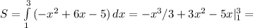-9+27-15+1/3-3+5=5 1/3

