$\left\{\begin{matrix}\frac{2x-3}{4}+\frac{3x-2}{3}>\frac{1}{12} \\ \frac{5x+1}{2}-\frac{8x-1}{5}<5\end{matrix}\right.$

$\frac{2x-3}{4}+\frac{3x-2}{3}>\frac{1}{12}$

$\frac{2x-3}{4}+\frac{3x-2}{3}-\frac{1}{12}>0$
$\frac{2x-3}{4}+\frac{3x-2}{3}-\frac{1}{12}>0$

$\frac{\left(2x-3\right)3}{4·3}+\frac{\left(3x-2\right)4}{3·4}-\frac{1}{12}>0$

$\frac{\left(2x-3\right)3+\left(3x-2\right)4-1}{12}>0$

$\frac{\left(6x-9\right)+\left(12x-8\right)-1}{12}>0$

$\frac{6x-9+12x-8-1}{12}>0$

$\frac{18x-18}{12}>0$

$\frac{18\left(x-1\right)}{12}>0$
$\frac{3\left(x-1\right)}{2}>0$

$3\left(x-1\right)>0$

x-1>0

x>0+1
x>1

$\frac{5x+1}{2}-\frac{8x-1}{5}<5$

$\frac{5x+1}{2}-\frac{8x-1}{5}-5<0$
$-5+\frac{5x+1}{2}-\frac{8x-1}{5}<0$

$-5+\frac{\left(5x+1\right)5}{2·5}-\frac{\left(8x-1\right)2}{5·2}<0$

$-5+\frac{\left(5x+1\right)5-\left(8x-1\right)2}{10}<0$

$-5+\frac{\left(25x+5\right)-\left(16x-2\right)}{10}<0$

$-5+\frac{25x+5-16x+2}{10}<0$

$-5+\frac{9x+7}{10}<0$

$-\frac{5·10}{10}+\frac{9x+7}{10}<0$

$\frac{-5·10+\left(9x+7\right)}{10}<0$
$\frac{-50+\left(9x+7\right)}{10}<0$

$\frac{-50+9x+7}{10}<0$

$\frac{-43+9x}{10}<0$

$\frac{9x-43}{10}<0$

9x-43<0

9x<0+43
9x<43

x<43:9
$x<\frac{43}{9}$

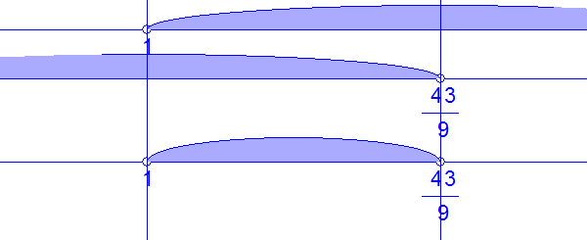
Окончательный ответ: $1<x<\frac{43}{9}$.

