The 4th of December, Friday

Classwork

1. Найдите данные слова на рисунке и переведите их на русский язык.

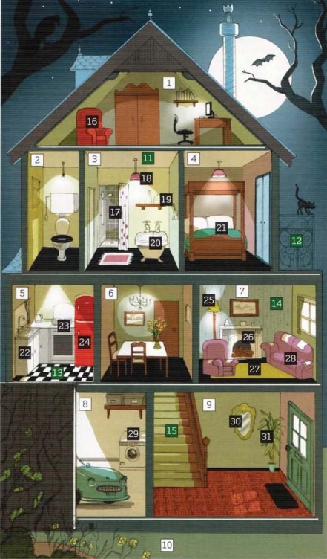
C. THINGS IN A ROOM (#16-31)

an armchair
a bath
a bed
a carpet
a cooker
a cupboard
a fireplace
a fridge
a lamp
a light
a mirror
a plant
a shelf (shelves)
a shower
a sofa
a washing machine

A. ROOMS (#1-10)

a bathroom
a bedroom
a dining room
a garage
a garden
a hall
a kitchen
a living room
a study
a toilet

B. PARTS OF A ROOM (#11-15)

a balcony
the ceiling
the floor
the stairs
the wall

REMEMBER!

the stairs
upstairs
downstairs

the FIRST FLOOR in Russia = the GROUND FLOOR in the UK.

2. Заполните таблицу, используя данные выражения.

Room | What we do  a). have a shower, b). cook dinner,  c). watch television, d). sit outside,  e). sleep in the bed, f). read newspapers,  g). drink a cup of tea, h). take a bath,  i). put on clothes, j). grow flowers
a kitchen
a living room
a bedroom
a bathroom
the garden

3. Выберите правильный вариант, переведите на русский язык.
1. There is / There are a bath in the bathroom. 2. There is / There are posters in my bedroom. 3. There isn´t / There aren´t a fireplace in our dining room. 4. There are / There aren´t any plants in my brother´s house. 5. There isn´t / There aren´t a computer in the hall. 6. There is / There are a fridge in the kitchen.

4.  05. Луиза и Эрик прибыли на выходные в Шотландию и остановились в гостинице the Craigdarroch Inn. Прослушайте диалог и укажите какие вещи имеются в гостинице, а какие отсутствуют:

□ a lift □ TV □ Wi-Fi □ a restaurant □ a bar □ a great view

5. Дополните диалог подходящими формами оборота there is / there are и, если необходимо, any.
- Hello. I´m interested in the flat to rent.
- Oh, OK. Let me tell you about it. (1) … a large living room and (2) … a small kitchen.
- (3) … a table in the kitchen?
- No, (4) … . But (5) … a very nice dining room with a table and some chairs.
- That´s fine. What about the bedrooms? How many bedrooms (6) … ?
- (7) … three bedrooms and a bathroom.
- (8) … a shower in the bathroom?
- Yes, (9) …
- Good. (10) … bookshelves in the living room?
- No, I´m sorry. But (11) … some cupboards.
- That´s OK. I think it´s perfect for us. How much is it?

6. Составьте предложения, используя предлоги места.

There is a ghost …
Призрак находится…

… behind… … in … … under …

… over … … in front of … …next to …

…between… … opposite … … on …

7. Опишите свой дом (квартиру), дополнив предложения.

My family is … (large, small). There are … (three, four, five…) of us: … (father, mother, my brother, my sister) and me. We all live in our … (house, flat). Each of us has his favourite place. My father’s favourite room is … (the living room). There are … (a flat-screen TV, a wall unit, a sofa, two armchairs). He usually … (watches TV, reads newspapers) there. My mother’s favourite place is our … (kitchen). She … (cooks there my favourite dishes, likes to sit with a cup of coffee). My favourite place is my … (bedroom). It isn´t large, but … (cosy, light, and stylish). The wall colour is … (light, dark). The furniture there is … (modern, stylish). There is … (a bed, a desk, a wardrobe) in my bedroom. I like … (to listen to music, to play computer games) there.

