https://znanija.com/task/24312053
$$y=2x^{2}-x^{4}$$

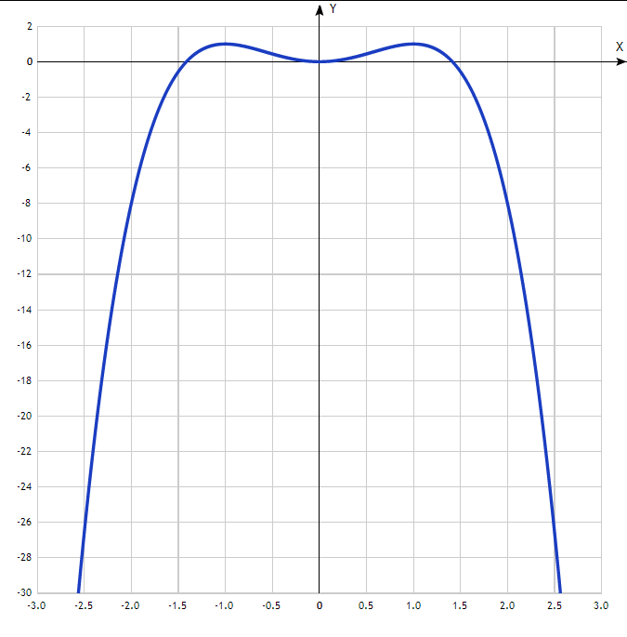
Таблица точек $y=2x^{2}-x^{4}$

x | y
-3.0 | -63
-2.5 | -26.6
-2.0 | -8
-1.5 | -0.6
-1.0 | 1
-0.5 | 0.4
0 | 0
0.5 | 0.4
1.0 | 1
1.5 | -0.6
2.0 | -8
2.5 | -26.6
3.0 | -63

