Все мы знаем, что в комнате должен быть порядок, но его – увы! – непросто поддерживать. Посмотрите на картинку, и вы увидите, что в комнате, где проживает рассеянный человек, не все на своих местах. Прочитайте предложения и выберите те, которые картинке соответствуют.
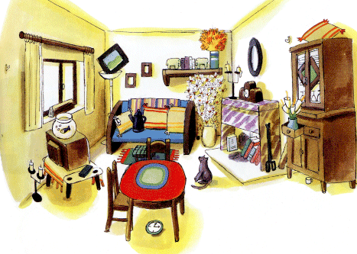
- A The dog is sitting in the centre of the room.
B The dog is lying on the sofa.
C The dog is looking at the cupboard.
- A There is a table and a chair in the room.
B There is a table and two chairs in the room.
C There is a table but there are no chairs in the room.
- A The fish bowl is on the table.
B The fish bowl is on the TV-set.
C The fish bowl is near the dog.
- A The flowers are near the window.
B The flowers are in front of the sofa.
C The flowers are near the wall.
- A The cupboard is behind of the sofa.
B The cupboard is in front of the window.
C The cupboard is behind the TV-set.
- A There is a tea pot on the table.
B There is a tea pot under the table.
C There is a tea pot on the sofa.
- A The clock is on the wall.
B The clock is in the shelf.
C The clock is under the table.
- A There are flowers on the windowsill.
B There is a picture under the windowsill.
C There is a strange object on the windowsill.
- A There is a vase on the cupboard.
B There is a pillow on the cupboard.
C There is nothing on the cupboard.
- A There is no TV-set in the room.
B The TV-set is under the shelf.
C The TV-set is near the window.

