7 клас І семестр
Speaking
Task . Imagine that while travelling during your holidays you took some photos. Choose one photo to present to your friend.
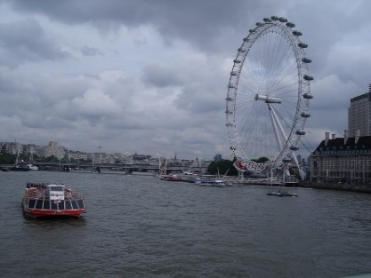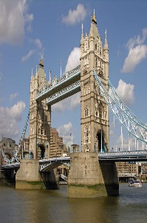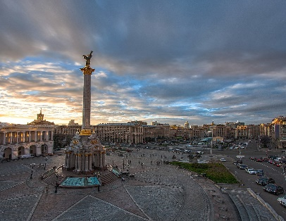

In your talk remember to speak about:
- when you took the photo
- what/who is in the photo
- what is happening
- why you took photo
- why you decided to show the picture to your friend
You have to talk continuosly, starting with:
I've chosen photo number...
You can use such phrases:
- In the picture you can see…
- On the left / on the right of the picture…
- In the foreground of the picture…
- In the background of the picture…
- In the middle of the picture…
- At the top of the picture…
- At the bottom of the picture…
- Next to
- Behind
- Near
- Under
- In front of

