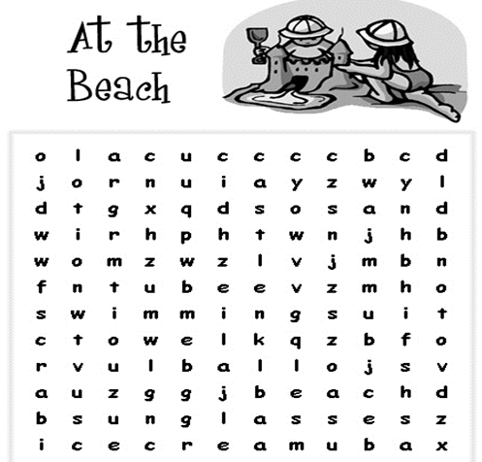
Beach
Sun
Swim
Ball

