у=х³-3х²-1
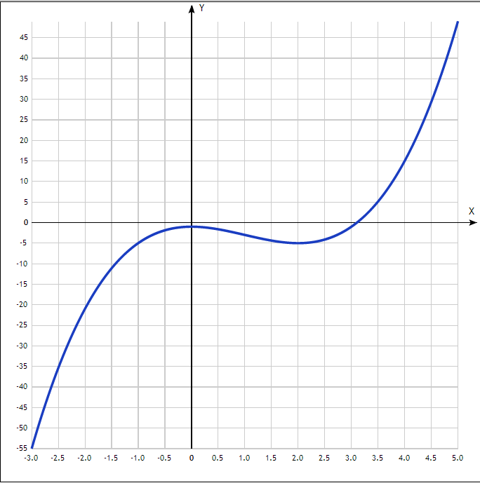

x | y
-3.0 | -55
-2.5 | -35.4
-2.0 | -21
-1.5 | -11.1
-1.0 | -5
-0.5 | -1.9
0 | -1
0.5 | -1.6
1.0 | -3
1.5 | -4.4
2.0 | -5
2.5 | -4.1
3.0 | -1
3.5 | 5.1
4.0 | 15
4.5 | 29.4
5.0 | 49

