$$y=x^{3}+x^{2}-16x-16$$

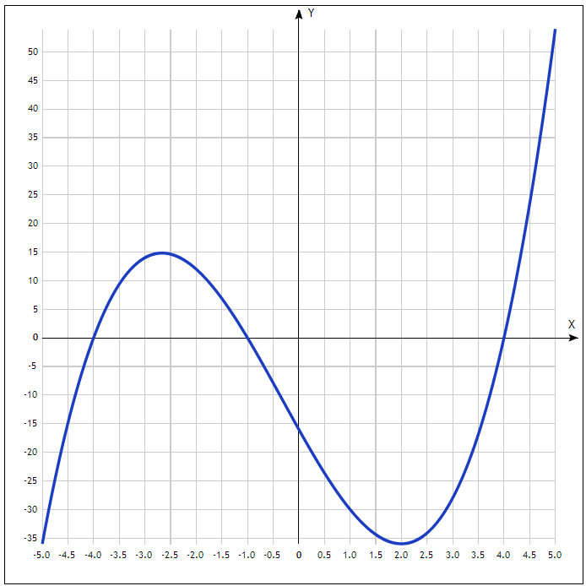
Таблица точек

x | y
-5.0 | -36
-4.5 | -14.9
-4.0 | 0
-3.5 | 9.4
-3.0 | 14
-2.5 | 14.6
-2.0 | 12
-1.5 | 6.9
-1.0 | 0
-0.5 | -7.9
0 | -16
0.5 | -23.6
1.0 | -30
1.5 | -34.4
2.0 | -36
2.5 | -34.1
3.0 | -28
3.5 | -16.9
4.0 | 0
4.5 | 23.4
5.0 | 54

