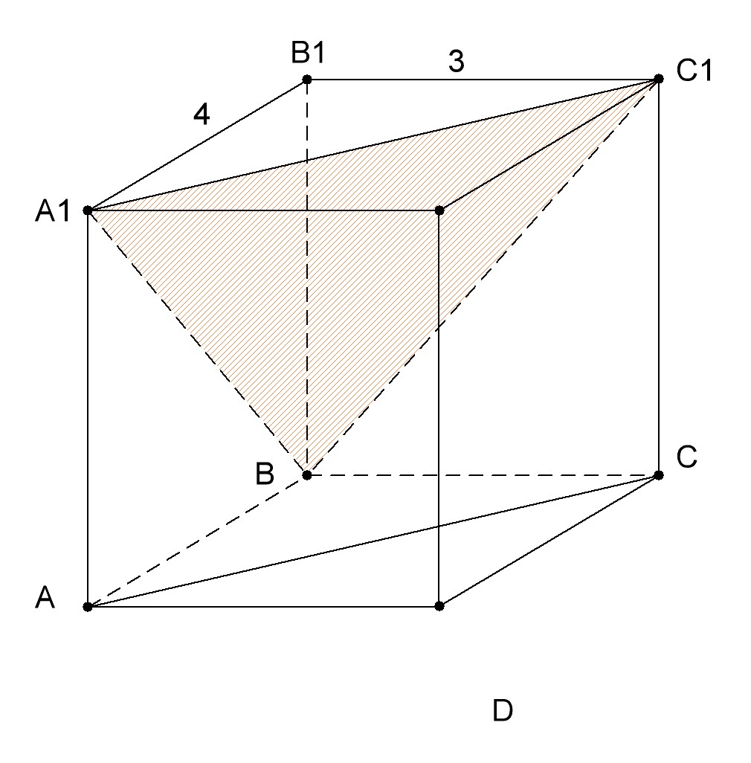
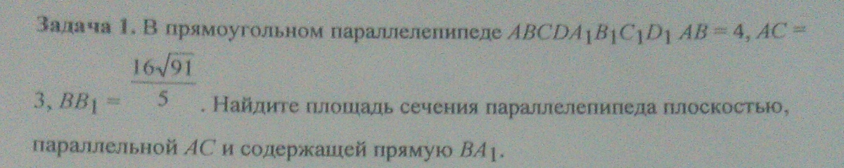
$$\begin{aligned}A_{1}C_{1}=\sqrt{4^{2}+3^{2}}=5 \\ A_{1}B=\sqrt{4^{2}+\frac{{\text{16}}^{2}∗\text{91}}{5^{2}}}=\frac{4}{5}\sqrt{5^{2}+4^{2}∗\text{91}}=\frac{4}{5}\sqrt{\text{1481}} \\ C_{1}B=\sqrt{3^{2}+\frac{{\text{16}}^{2}∗\text{91}}{5^{2}}}=\frac{1}{5}\sqrt{{\text{15}}^{2}+{\text{16}}^{2}∗\text{91}}=\frac{1}{5}\sqrt{\text{23521}}\end{aligned}$$
По формуле Герона получаем
$S=\sqrt{\text{5680}}$

