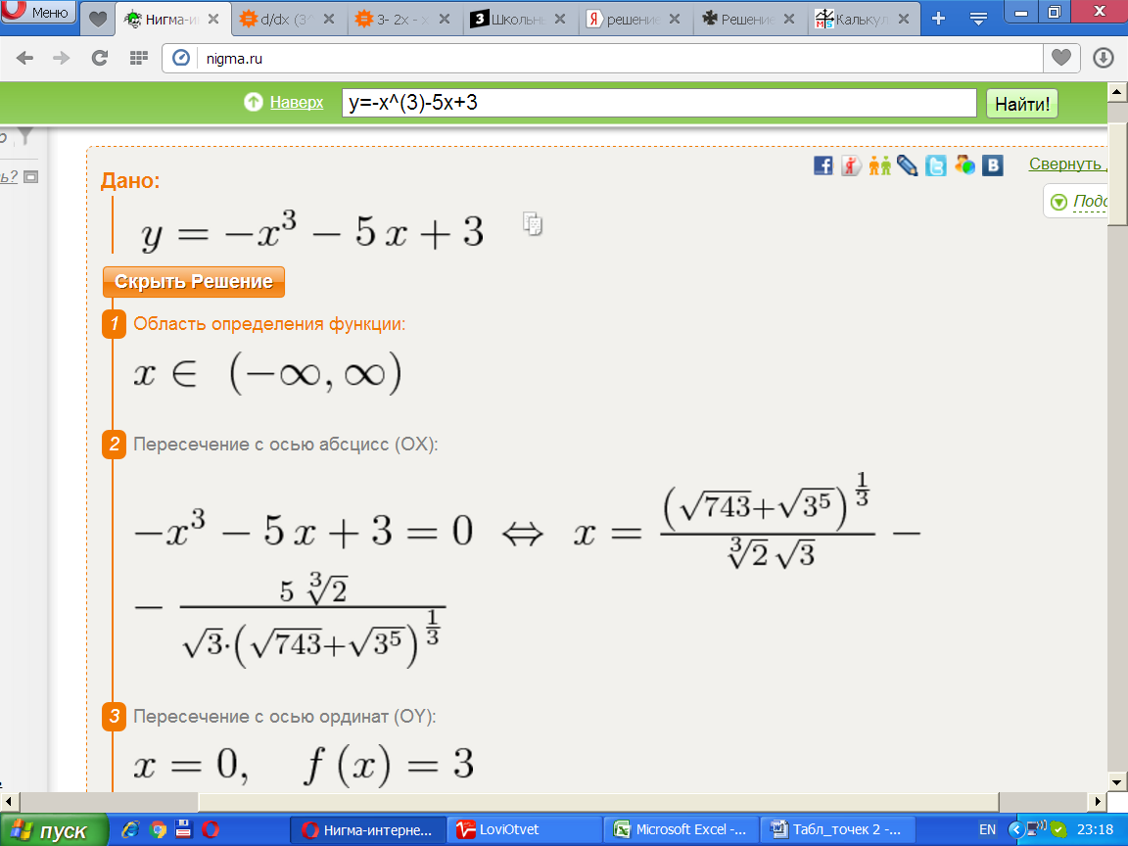x≈0.56410 - это точка пересечения с осью ОХ.

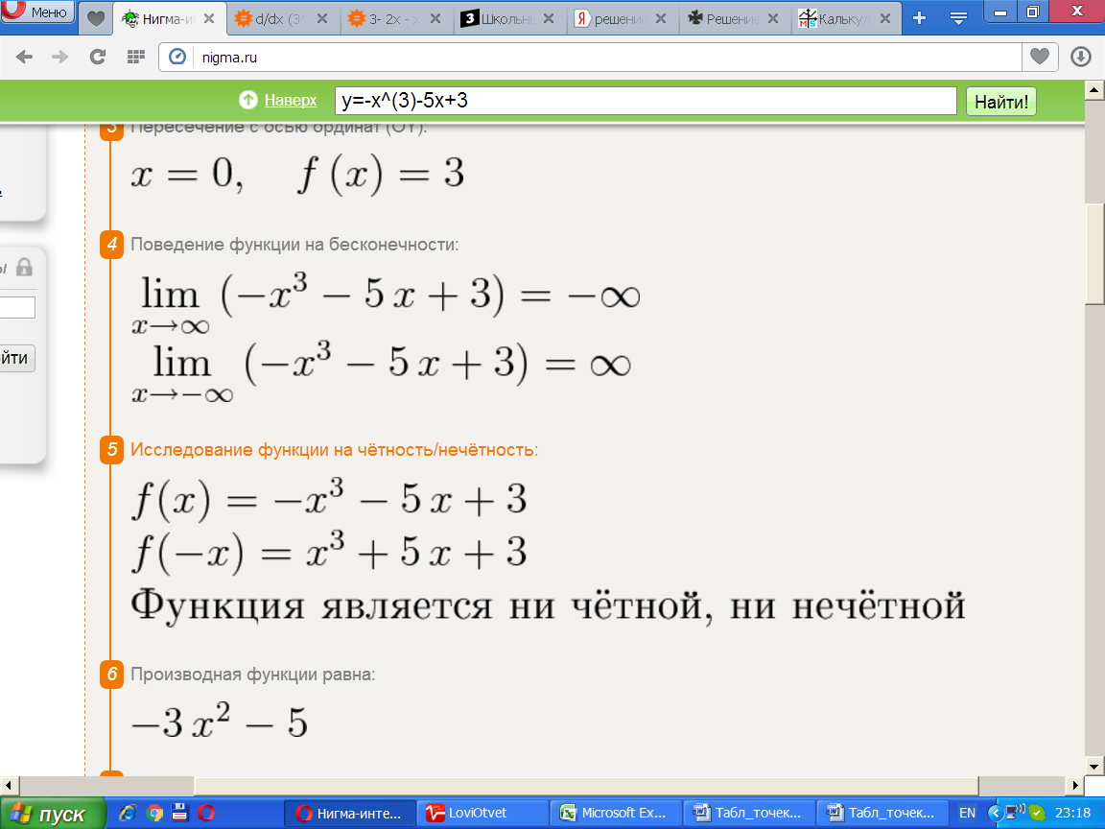

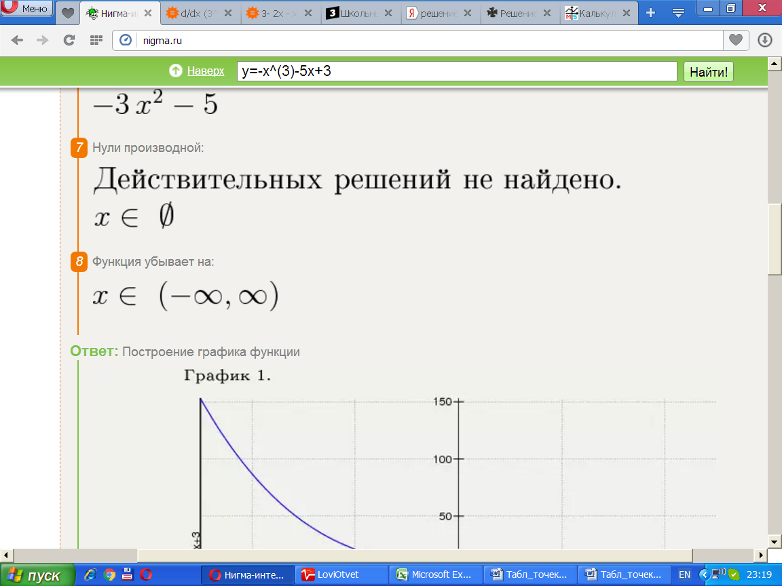

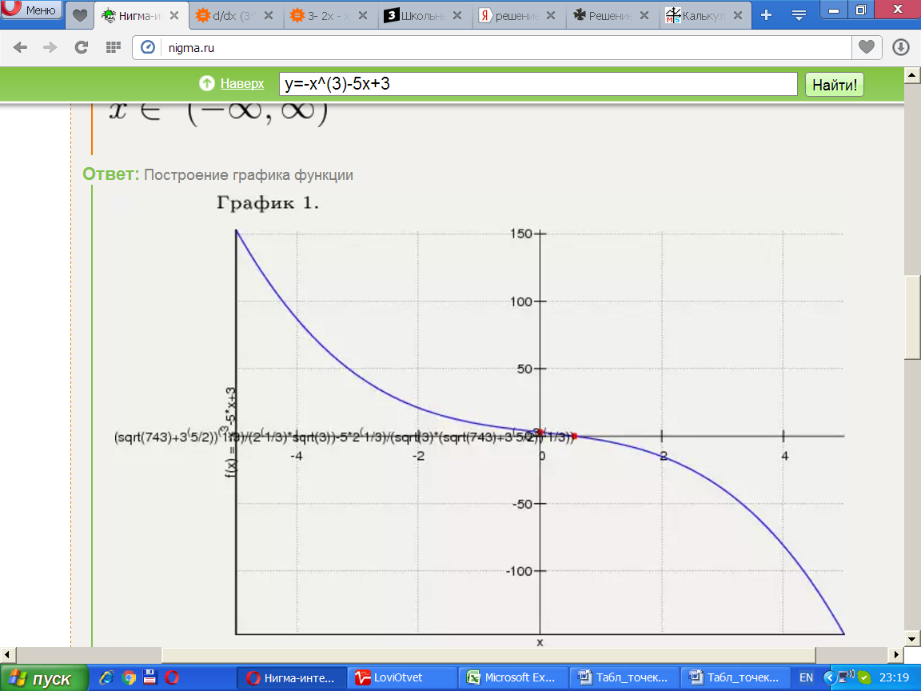

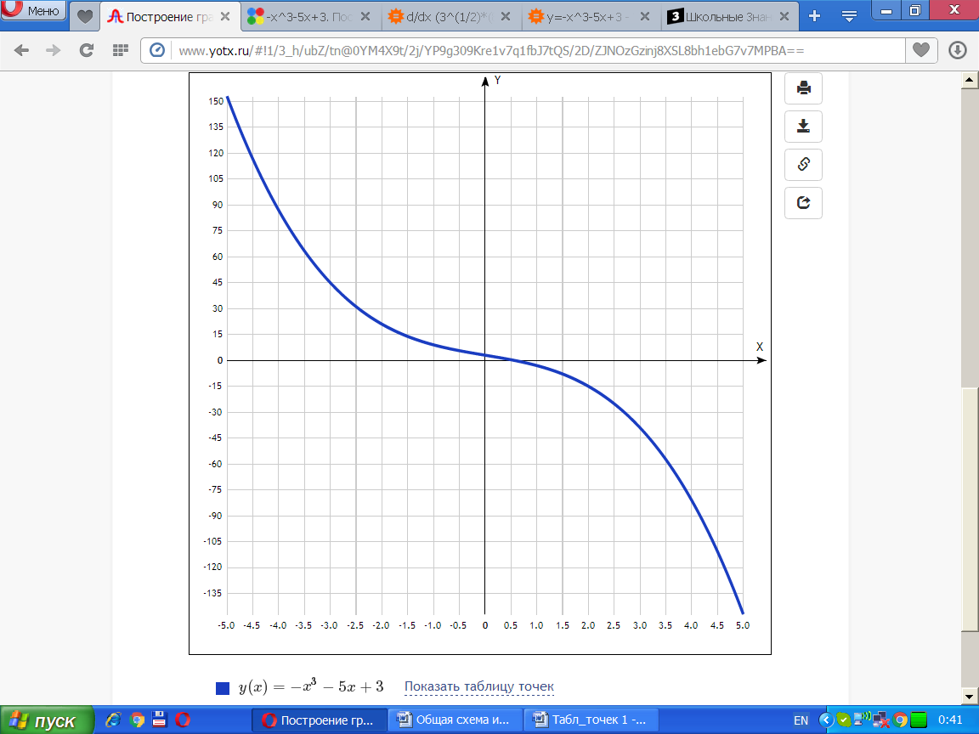

y(x)=−x3−5x+3 [Таблица точек](javascript:void(0);)

|  |  |
| --- | --- |
| **x** | **y** |
| -5.0 | 153 |
| -4.5 | 116.6 |
| -4.0 | 87 |
| -3.5 | 63.4 |
| -3.0 | 45 |
| -2.5 | 31.1 |
| -2.0 | 21 |
| -1.5 | 13.9 |
| -1.0 | 9 |
| -0.5 | 5.6 |
| 0 | 3 |
| 0.5 | 0.4 |
| 1.0 | -3 |
| 1.5 | -7.9 |
| 2.0 | -15 |
| 2.5 | -25.1 |
| 3.0 | -39 |
| 3.5 | -57.4 |
| 4.0 | -81 |
| 4.5 | -110.6 |
| 5.0 | -147 |