https://znanija.com/task/24417812 $y=-{\left(x-2\right)}^{2}+9$

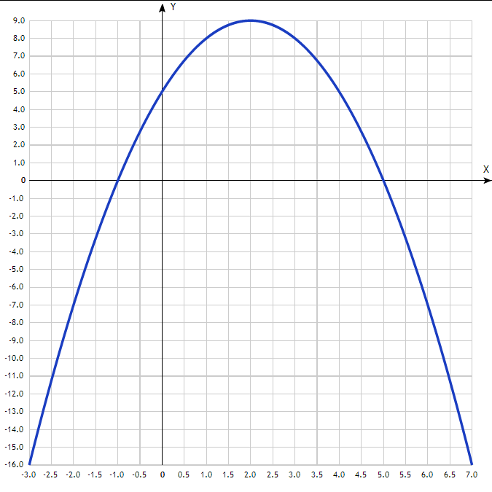
Таблица точек

x | y
-3.0 | -16
-2.5 | -11.25
-2.0 | -7
-1.5 | -3.25
-1.0 | 0
-0.5 | 2.75
0 | 5
0.5 | 6.75
1.0 | 8
1.5 | 8.75
2.0 | 9
2.5 | 8.75
3.0 | 8
3.5 | 6.75
4.0 | 5
4.5 | 2.75
5.0 | 0
5.5 | -3.25
6.0 | -7
6.5 | -11.25
7.0 | -16

