Прочитайте текс и напишите о своем любимой животном, отвечая на вопросы и опираясь на этот текст.
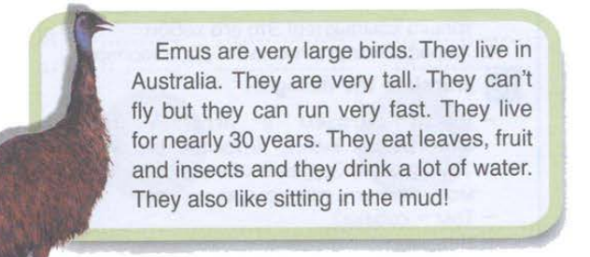

- What does your favourite animal look like?
- Where does it live?
- How long does it live?
- What does it like?
- What does it eat?
- Why do you like this animal?

