SUMMATIVE ASSESSMENT
IV TERM
Task 1. Read the text and choose the correct statement T or F.
Dear Alex,
My name is Fred. I am ten. I am from New Zealand. I live with my mum, dad and two sisters Kate and Mary. They are six. The girls like fairy tales. What is your name? How old are you? Have you got a sister or a brother? My birthday is on the 18th of September. Summer is my favorite season. In summer I Ride my bike, swim and play football. I like to play tennis too. What do you like to do? I have got a black cat Harry. It is nice and funny. It likes to play with a ball. Harry likes milk and fish. I like my cat but I would like to have a dog and a parrot. Have you got a pet?
Best wishes, Fred
1) The boy`s name is John. ________
2) The boy likes to read books. _______
3) His cat's favorite dish is milk. _______
4) The boy wants to have a parrot and a mouse.
4/_
Task 2. Write suggestions for plans for outdoor recreation this weekend. Use to be going to.
Example: we / make a fire – We’re going to make a fire.
- Dad / look for wood - _______________________________________________.
- Dad and Charlie / put up the tent -_____________________________________.
- Mum and Molly / make the beds_______________________________________.
- Mum / cook dinner - ________________________________________________.
- Harry / play with his toys - ___________________________________________.
5/_
Task 3. Look and write.
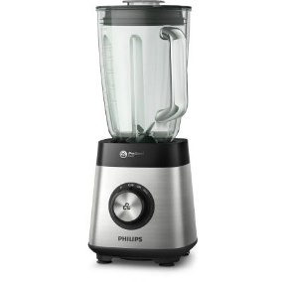
_______________ _________________ _______________

___________________ ____________________ ________________
6/_

15/__

