Skeletal System – Скелетная система
Task 1
- Соедините название наук с их областями изучения.
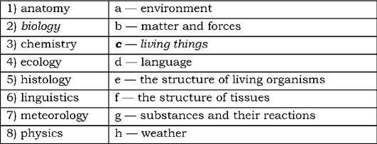
1) - _； 2) - c; 3) - _; 4) - _; 5) - _; 6) - _; 7) - _; 8) - _.
B. Используя вышеприведенную таблицу, составьте предложения.
Example: Biology studies living things. – Биология изучает живые организмы.
1. _
2. _
3. _
4. _
5. _
6. _
7. _

Task 2
A. Используя слова из рамки, соотнесите их с русскими терминами и запишите транскрипцию, используя словарь.
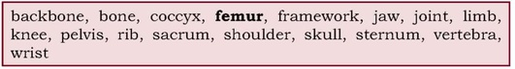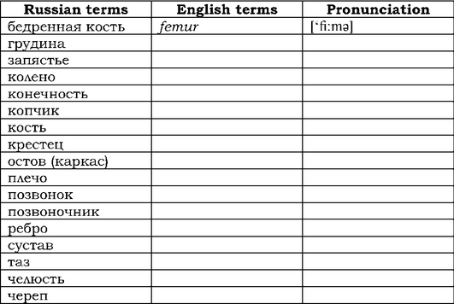
Task 3.
A. Read and translate the following international words: biological, chronic, function, group, infection, system, type.
B. Match the words of the Latin origin on the left (A) with their
English equivalents on the right (B). Соедините слова латинского происхождения из колонки (А) с их английскими эквивалентами из колонки (В).
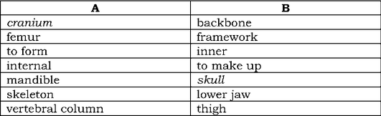
1) cranium - skull
2) _ _
3) _ _
4) _ _
5) _ _
6) _ _
7) _ _
C. Translate the words with the same roots. (If you know the meanings of suffixes, you can easily recognize nouns and adjectives.) Переведите слова с одинаковыми корнями. (Если вы знаете значение суффиксов, то вы сможете легко распознать существительное и прилагательное).
1 - skeleton, skeletal_
2 - pelvis, pelvic_
3 - protection, protective_
4 - cranium, cranial_
5 - bone, bony_
6 - infection, infective_
7 - move, movable_
8 - vertebra, vertebral_
Task 4. Now you are going to read a text about the human skeleton. Прочитайте и УСТНО переведите текст Скелет.
A. Read and translate the headings for the paragraphs of the text "The Skeleton": Прочитайте и переведите заголовки к параграфам текста Скелет:
1 - Functions of the skeleton
2 - Skeletal system of the body
3 - Structure of the pelvis
4 - Bony framework of the head
B. Look through the text and match each heading with the correct paragraph. Озаглавьте каждый параграф вышеприведенными заголовками.
THE SKELETON
1_
Man, as a member of the great group of vertebrates, has an internal skeleton as a framework for his body. There are more than 200 bones in the human skeleton. Collectively they make up the skeletal system of the body. There are two parts of the skeleton: the axial skeleton, 80 bones, and the appendicular skeleton, 126 bones. The bones of the limbs form the appendicular skeleton. The axial skeleton includes the skull, the backbone, and the ribs and sternum. The most important of these is the backbone, or vertebral column; it consists of 26 separate bones, the vertebrae, one on top of the other.
2_
At the top of the backbone there is the skull, the bony framework of the head. It includes more than twenty bones and consists of two parts, the cranium and the facial section. The cranium is the top, back, and sides of the skull. At birth, the skull joints are flexible and remain so until around the second year of life. The facial bones are smaller and more complex than the cranial bones. None of them is movable, except the mandible.
3_
At the lower end of the backbone, there is the pelvic girdle. This girdle and the last two bones of the backbone, the sacrum and the coccyx, form the pelvis. In each side of the pelvis there is a socket into which the femur, or thigh bone, fits. Man's erect posture is dependent upon the structure of the pelvis.
4_
The functions of the skeleton are of three different types - support, protection and motion. Some bones have chiefly a protective function. An example is the skull, which encloses the brain, the back of the eyeball, and the inner ear. Some, such as pelvis, furnish the main support for the body. Other bones, such as jaw and the bones of the fingers, help the body move. Of these functions, support is the most primitive and the oldest.
Task 5.
A. Fill in the gaps with the anatomical terms from the box. (Use the dictionary if necessary.) Заполните пропуски анатомическими терминами из рамки согласно тексту.
1. There are two parts of the skeleton: the ... skeleton and the ... skeleton.
2. The axial skeleton includes the ..., the ..., and the ... and sternum.
3. The backbone consists of 26 separate bones, the ....
4. At birth, the skull joints are ....
5. At the lower end of the backbone, there is the pelvic . B. Read and translate the sentences.

