$$y=log₅x$$
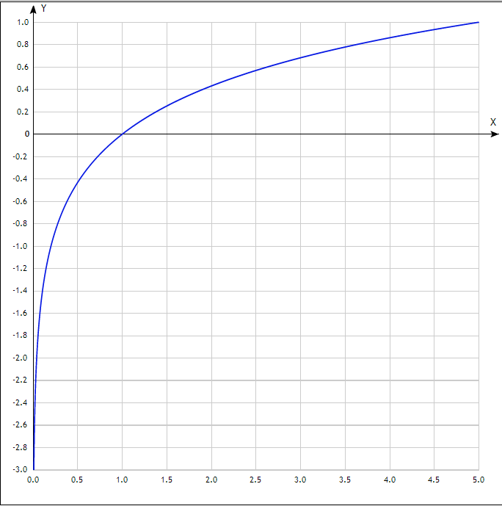

x | y
0.0 | -
0.5 | -0.43
1.0 | 0
1.5 | 0.25
2.0 | 0.43
2.5 | 0.57
3.0 | 0.68
3.5 | 0.78
4.0 | 0.86
4.5 | 0.93
5.0 | 1

