Reading Comprehension Text p178-9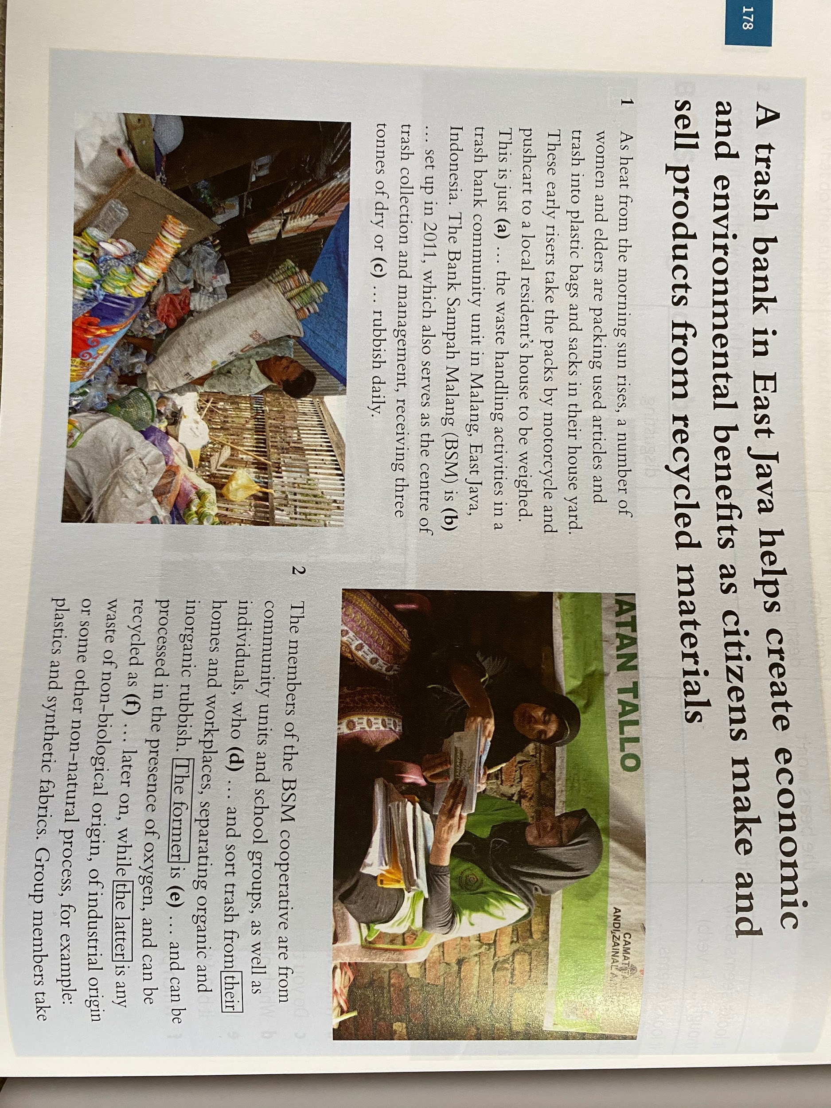
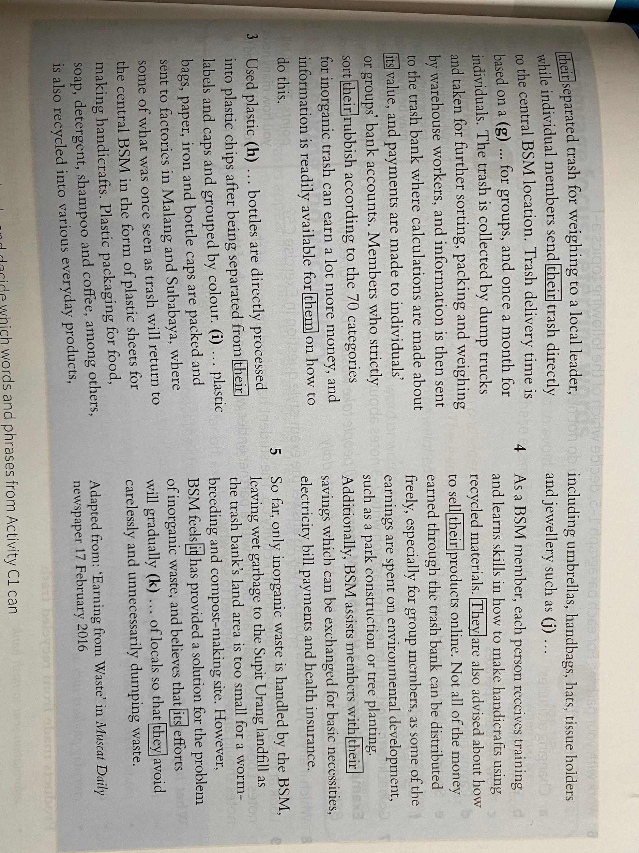

Read the text above. Look up any words you are unsure of. Answer sections A, B, C and D below, typing your answers in the red sections.

A) Choose the best headline from the list below:

- 70 categories for organic waste
- Earning money from waste
- Citizens’ handicrafts for sale
- Differences between organic waste
- Trash, garbage, rubbish, waste - it’s all the same to us

Best headline =

[1 mark]

B) Look at the following phrases. Which can fit into spaces (a) - (k) in the text?

shape the mindset beverage biodegradable consensus a cooperative
discarded brooches fertiliser and compost gather inorganic a glimpse of

(a)
(b)
(c)
(d)
(e)
(f)
(g)
(h)
(i)
(j)
(k)

[11 marks]

C) Look at this exam-style question.

You have been asked by your teacher to make a presentation to students about the BSM system and you need to make notes in order to prepare. Make short notes under each heading.

What happens after trash collection
- Trash taken for sorting and packing

Products made from recycled trash

How BSM helps its members

[9 marks]

D) Choose the best heading from the list below for each numbered paragraph (1-5) in the text. There is one heading that you will not need.

A Changing attitudes
B Handicraft products
C How the BSM operates
D Paying bills
E Sorting, collection and delivery of waste
F Selling products online

[Total 26 marks]

