(357+256+149)-429=333

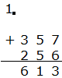
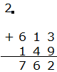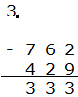

904-(127+209+316)=252

