U4 Short Test 1 (ABC)
- Complete the magazine interview. Use the past simple or present perfect form of the verbs in brackets.
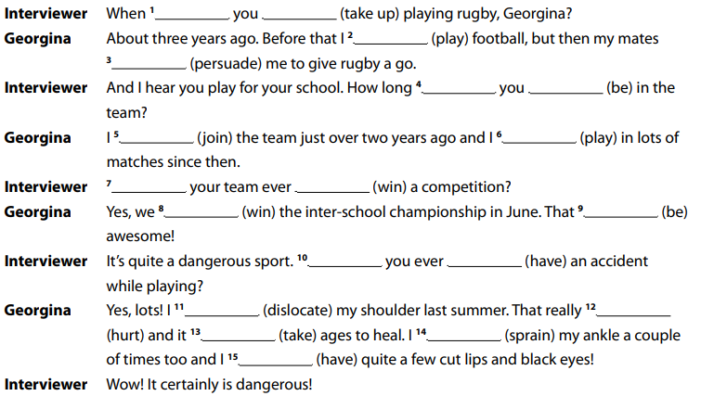

- Complete the sentences. Use the past simple or present perfect form of the verbs below.
become go have hurt meet not go play post read not see
- What’s the matter? ________ you ________ yourself?
- Let’s go out for dinner tonight. We _______________ to a restaurant for months.
- ‘Where’s Tom?’ ‘He _______________ to Barcelona last month.’
- How long ________ he ________ that rash? It looks painful.
- Why ________ yoga ________ so popular in the past few years?
- We _______________ our holiday photos on Facebook last night.
- ‘________ you ________ your wife at university?’ ‘No, we were at school together.’
- ‘Shall we go and see that new action film tonight?’ ‘Yes, good idea! I _______________ it yet.’
- ‘Was Mimi at football yesterday?’ ‘Yes. She _______________ really well.’
- What books ________ you _________recently?

3 Complete the sentences with the words below. There is one word that you do not need.
awareness campaign illegal law right tax
- Parliament is passing a new __________ to deal with drink-driving.
2 We hope to raise public __________ of animal rights.
3 The government has launched a big __________ to make school lunches healthier.
4 Has the Governor of California really made rollerblading in parks __________?
5 Do they have the __________ to ban smoking in all public places?

