http://www4f.wolframalpha.com/Calculate/MSP/MSP14621c27e6953ah64g1h0000229d178904c0ega5?MSPStoreType=image/gif&s=7&w=200.&h=35.

Это выражение равносильно:

http://www4f.wolframalpha.com/Calculate/MSP/MSP14671c27e6953ah64g1h00001g6h6g4a0eg68ehb?MSPStoreType=image/gif&s=7&w=166.&h=36.

http://www4f.wolframalpha.com/Calculate/MSP/MSP15801c27e5h07cgh555100003f75a850a0i8554h?MSPStoreType=image/gif&s=7&w=147.&h=36.

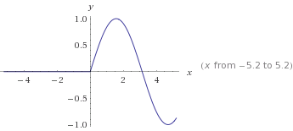

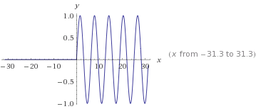

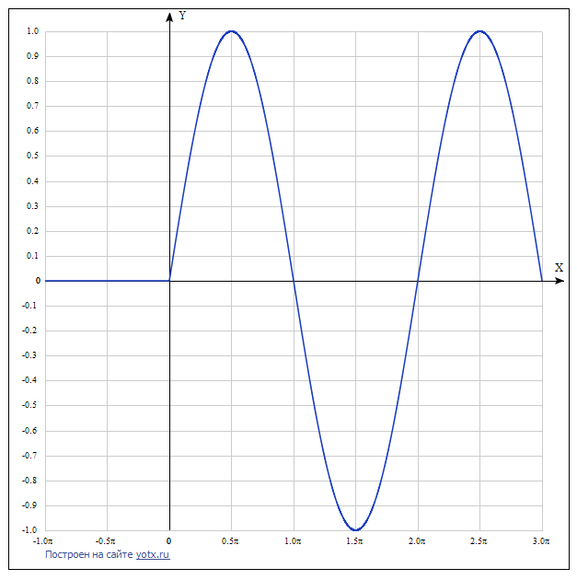

y(x)=|x|sin(x)/2x+cos(π2−x)/2

[Таблица точек](javascript:void(0);)

|  |  |
| --- | --- |
| **x** | **y** |
| -1.0π | 0 |
| -0.5π | 0 |
| 0 | - |
| 0.5π | 1 |
| 1.0π | 0 |
| 1.5π | -1 |
| 2.0π | 0 |
| 2.5π | 1 |
| 3.0π | 0 |