1

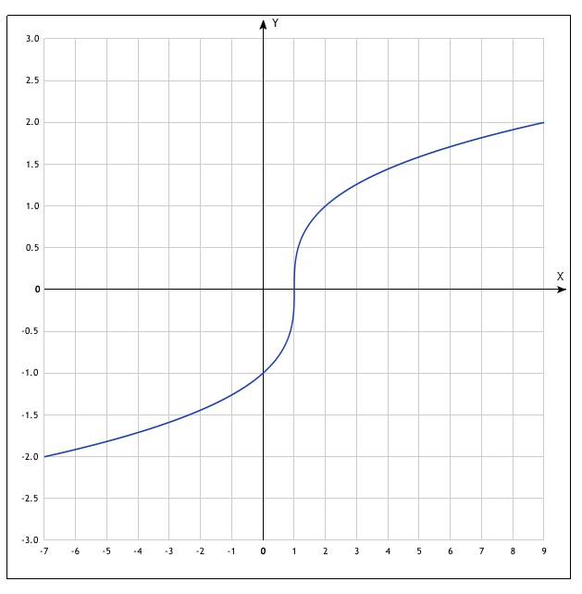

|  |  |
| --- | --- |
| **x** | **y** |
| -7 | -2 |
| 0 | -1 |
| 1 | 0 |
| 2 | 1 |
| 9 | 2 |

2

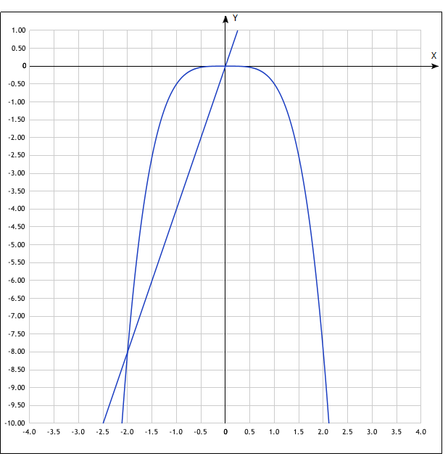

*y*(*x*)=−*x* ^4/2

|  |  |
| --- | --- |
| **x** | **y** |
| -2.0 | -8 |
| -1.0 | -0.5 |
| 0 | 0 |
| 1.0 | -0.5 |
| 2.0 | -8 |

Y(x)=4x

|  |  |  |
| --- | --- | --- |
| **x** | **y** | |
| 1.0 | -4 |
| -0.5 | -2 |
| 0 | 0 |
| 0.5 | 2 |
| 1.0 | 4 |