10-sinf 4-chorak

**Test**

**Variant I**

1. @ is called ‘little snail’ in ….

A) Greece B) France C) Poland D) Sweden

2. In Denmark @ is often called …….

A) little dog B) ear C) pig’s tail D) little duck

3. 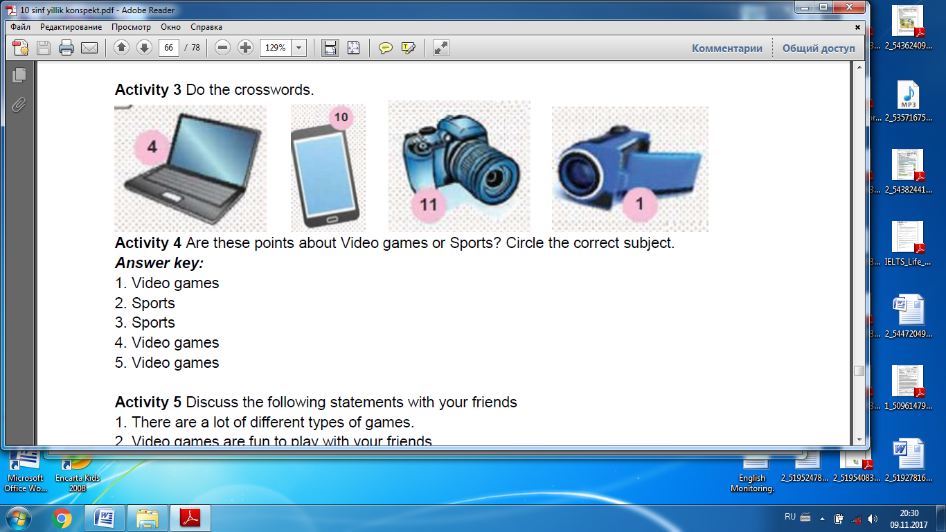Find the correct definition

A) a portable phone B) an immovable phone

C) a headphone D) speakers

4. Ray Tomlinson is a man who ………

A) invented the Net B) invented @

C) invented @ and email D) invented email

5. Find the correct genre to Xudoyberdi Tukhtaboyev

A) detective B) children’s literature  
C) comedy D) happiness singer

6. What are the advantages of computers?

A) social skills, waste of time,

B) researching, information, online education

C) Insomnia, lack of creativity, online education

D) cheating, physical inactivity, online assignment help

7. Find the correct preposition. Today we talked …Ray Tomlinson.

A) to B) with C) at D) –

8. He hates cables that’s why he has a …… mouse and ………

A) keyboard, web B) wireless, keyboard  
C) homepage, wireless D) download, webcam

9. ”My computer isn’t functioning well”-Jamil said.

A) Jamil said that my computer wasn’t functioning well.  
B) Jamil said that her computer wasn’t functioning well  
C) Jamil said that his computer was functioning well  
D) Jamil said that his computer wasn’t functioning well.

10. Find the best word to fill the gap.  
It’s the best way to ….physically fit and healthy.

A) go B) stay C) stand D) run

11.Which is not a connector for adding ideas

A) in addition B) as well as C) but D) also

12.What does the ‘PC’ stand for?

A) Personal computer B) Personal company  
C) Personal charity D) Personal website

13. Fitrat was born in … in 1886.

A) Bukhara B) Samarkand C) Khiva D) Kokand

14. In 1587 William ……

A) went back to Stratford B) performed his plays  
C) worked for James I D) went to London

15. Who declares that she will marry anyone, who wins all four contests?

A) Barchin B) Xolbeka C) Zulhumor D) Tillaqiz

**Variant II**

1. What are the advantages of computers?

A) social skills, waste of time,

B) researching, information, online education

C) Insomnia, lack of creativity, online education

D) cheating, physical inactivity, online assignment help

2. Find the correct preposition. Today we talked …Ray Tomlinson.

A) to B) with C) at D) –

3. He hates cables that’s why he has a …… mouse and ………

A) keyboard, web B) wireless, keyboard  
C) homepage, wireless D) download, webcam

4. @ was invented in ….

A) 1970 B) 1972 C) 1994 D)1971

5. @ is called ‘little snail’ in ….

A) Greece B) France C) Poland D) Sweden

6. In Denmark @ is often called …….

A) little dog B) ear C) pig’s tail D) little duck

7. Find the correct definition of the ‘freeze’

A) make a journey B) extremely cold

C) living in natural environment D) place with temporary accommodation

8. ‘Sherlock Holmes’ was written by…..

A) Jack London B) Hengry Green  
C) Arthur Konan Doyle D) Elizabeth Bower

9. Find the play which were written by William Shakespeare

A) Antony and Cleopatra B) Magus  
C) White Fang D) Loving

10. Find the correct genre to Xudoyberdi Tukhtaboyev

A) detective B) children’s literature  
C) comedy D) happiness singer

11. Where did Fitrat study during 1909-1913?

A) Jadid’s school B) ‘Buhoro ta’limi maorifi’  
C) ‘Mir Arab’ D) Dorul Muallimin

12. Whose uncle was uzbek writer and interpreter Mirzakalon Ismoiliy ?

A) Oybek B) Utkir Hoshimov  
C) Tohir Malik D) Abdulla Qodiriy

13.Who has written a famous crime novel called “Shaytanat”?

A) Utkir Hoshimov B) Tohir Malik  
C) Abdulla Qodiriy D) Oybek

14. Who is the author of ‘Richard II’ ?

A) Hengry Green B) William Shakespeare  
C) Jack London D) Arthur Konan Doyle

15. What was the name of the first theatre William Shakespeare worked in?  
A) Globe Theatre B) Stradford C) The Rose D) unknown