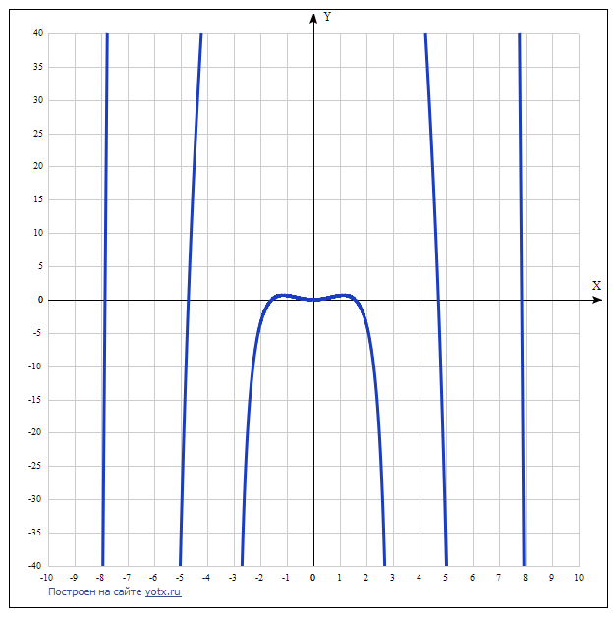

y(x)=x³ctg(x) Таблица точек

x | y
-10 | 1542.4
-9 | -1611.7
-8 | -75.3
-7 | 393.6
-6 | -742.3
-5 | -37
-4 | 55.3
-3 | -189.4
-2 | -3.7
-1 | 0.6
0 | -
1 | 0.6
2 | -3.7
3 | -189.4
4 | 55.3
5 | -37
6 | -742.3
7 | 393.6
8 | -75.3
9 | -1611.7
10 | 1542.4

