5 Complete the sentences with the correct words. The first letter of each word has been given.
0 She likes listening to the radio when she is alone in the house.
1 I am having a big p_______ for my birthday.
2 My mum does y_______ to help her relax.
3 H_______ students always pass their exams.
4 He’d like to be a j_______ and work for a newspaper.
5 I always wear g_______ when I swim.
6 She f_______ our cats every morning
7 I never feel l_______ when my parents are away.
8 I always wear a h_______ when I go cycling.
9 They all felt very t ___________ after the race.
10 It’s a good idea to wear a w_______ when diving in cold water.
10
Listening
2 2 Listen to two people talking about sport. Choose the best answer to the questions.
1 Which of these sports is not in an Ironman competition?
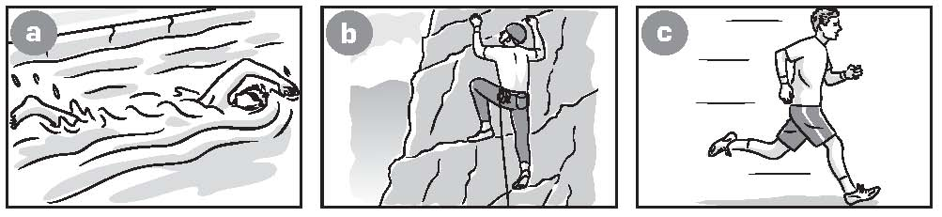
2 What sport does Jan find difficult?
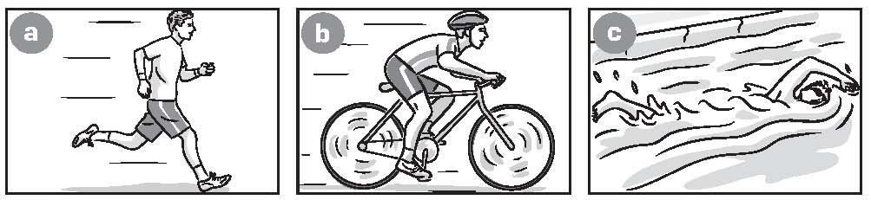
3 What sport does Jan do on Tuesdays and Fridays?
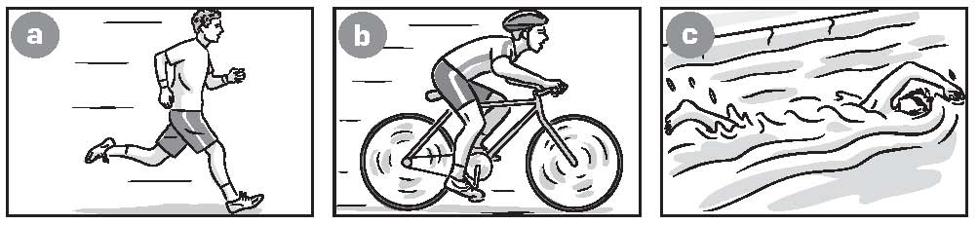

4 What does Jan do when he goes to the park on Sunday?
/4
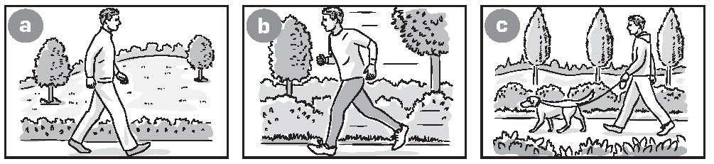
Communication
3 Choose the correct words to complete the sentences.
0 It’s definitely/maybe sunny. People are wearing sunglasses.
1 There are lots of children in the park. It is perhaps/definitely the school holidays.
2 Who is the man on the right/middle of the photo?
3 I enjoy running because/maybe it is good exercise.
4 Who is the woman in/on the middle of the group?
5 It’s definitely/perhaps nighttime. It’s very dark.
6 Your parents are in/on the foreground of the photo.
/8
7 What can you see in the background/left? Mountains?
8 I think the swimmer on the middle/left is from Australia.
TOTAL SCORE:22

