**________КГУ «ШИ № 4»_______________________________________________   
(наименование организации образования)**

**Поурочный план или краткосрочный план для педагога организаций среднего образования**  
______________________________________________(тема урока)

**Раздел: Reading for pleasure**

**Ф.И.О. педагога: Abisheva Zh.M.**

**Дата: 16.02.2021**

**Класс: 5 “A” Количество присутствующих: Количество отсутствующих:**

**Тема урока:** Review

**Цели обучения с соответствии с учебной программой:**

**Цели урока:** 5.R5 Deduce meaning from context in short texts on a limited range of familiar general and curricular topics

5.R8 Use with some support familiar paper and digital reference resources to check meaning and extend understanding

**ORGANISATION MOMENT**

**Warm up.**

***1. Greeting***

**Good morning?**

**Glad to see you.**

**How are you?**

**What is the day today?**

**What the weather like today?**

**Exercise-1. Answer the questions! Ответьте на вопросы!**

1. How much time do you spend on reading?
2. What kind of reading do you prefer: do you like reading books? newspapers? magazines?
3. Do you read books only for your Russian Literature classes or do you do any extra reading?
4. How old were you when you began reading? Do you remember what book was the first that you read?
5. Do you collect books? How many books do you have at home?
6. What does reading do for you? Is it important part of your life? In what way can reading be useful to people?

**Exercise-2.Read the text! Write true or false! Прочитайте текст и напишите правильно или неправильно по тексту!**

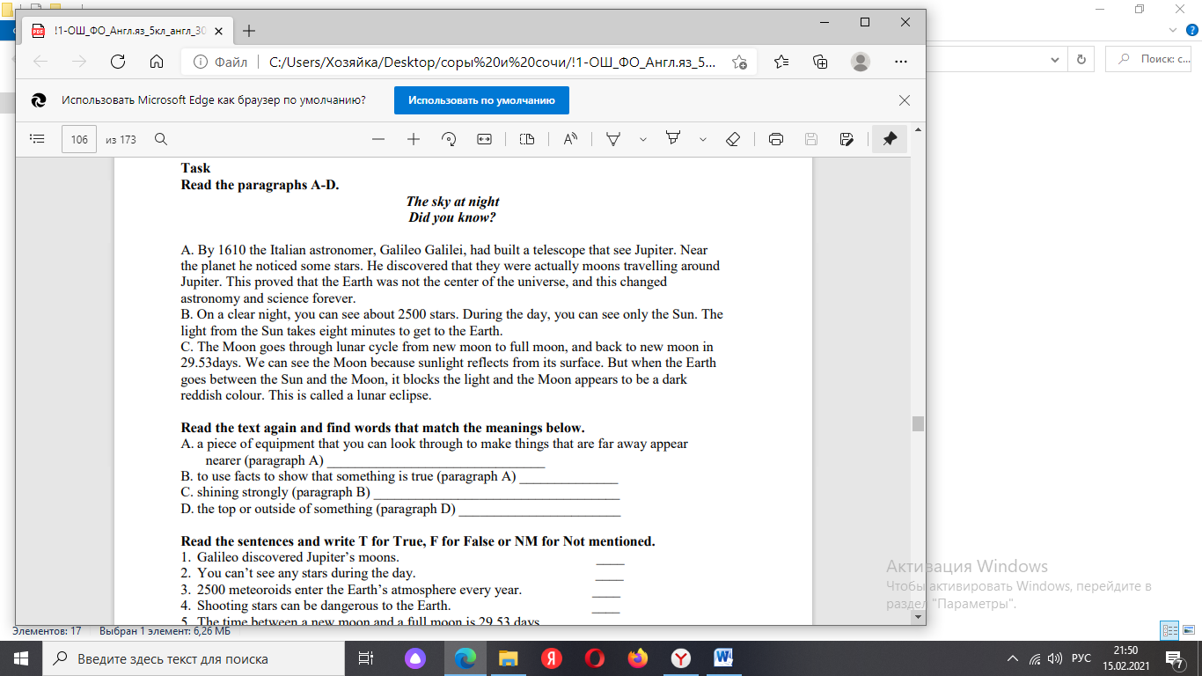

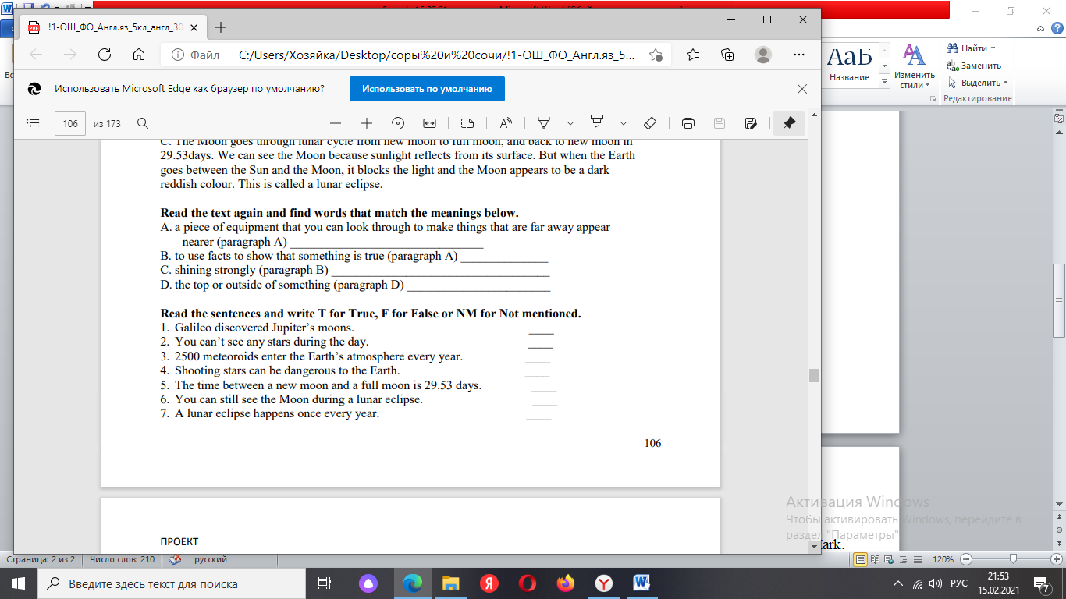

Обратная связь: Send the voice message and the text to your teacher by WhatsApp or EduMark.