https://znanija.com/task/24506799

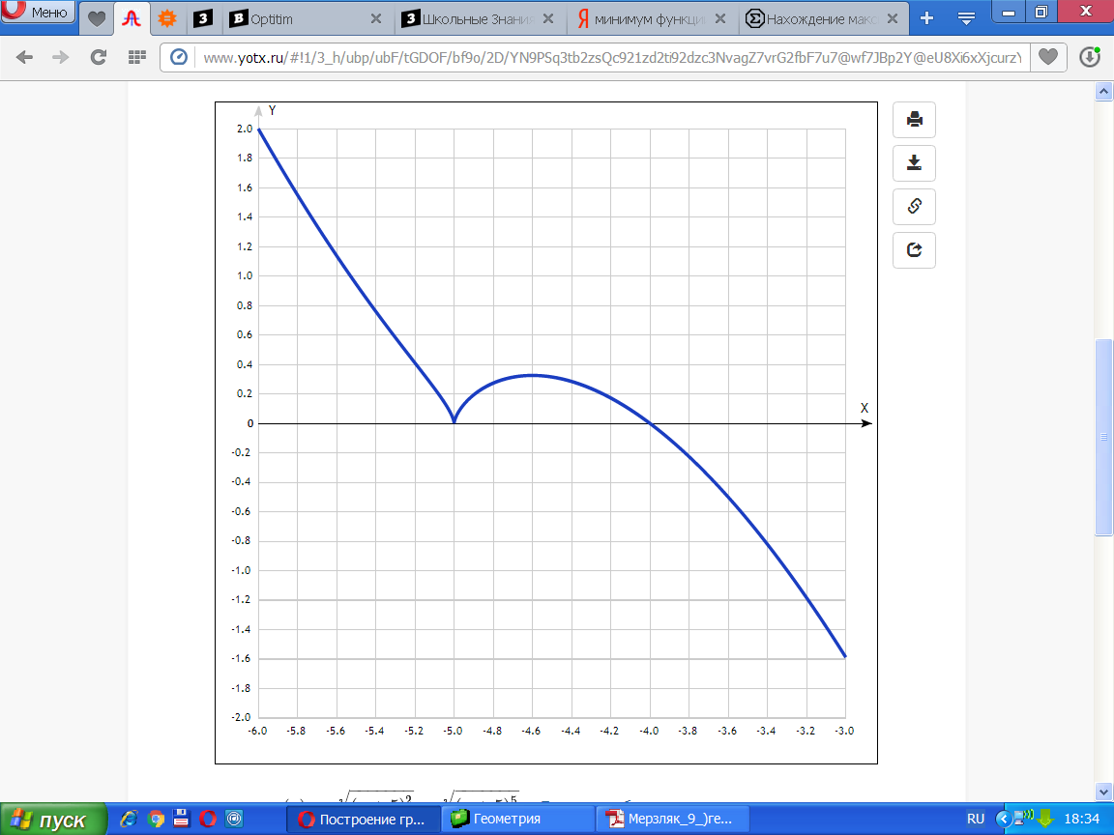

[Таблица точек](javascript:void(0);)

|  |  |
| --- | --- |
| **x** | **y** |
| -6.0 | 2 |
| -5.8 | 1.55 |
| -5.6 | 1.14 |
| -5.4 | 0.76 |
| -5.2 | 0.41 |
| -5.0 | 0 |
| -4.8 | 0.27 |
| -4.6 | 0.33 |
| -4.4 | 0.28 |
| -4.2 | 0.17 |
| -4.0 | 0 |
| -3.8 | -0.23 |
| -3.6 | -0.5 |
| -3.4 | -0.82 |
| -3.2 | -1.18 |
| -3.0 | -1.59 |