$$z=4x^{2}+y^{2}-36x-6y+90$$
Проверяем наличие глобального экстремума:
$$\left\{\begin{aligned}z_{x}^{'}=8x-36=0 \\ z_{y}^{'}=2y-6=0\end{aligned}\right.→x=4.5;y=3 \\ A=z_{xx}^{''}=8;B=z_{xy}^{''}=z_{yx}^{''}=0;C=z_{yy}^{''}=2 \\ ∆=AC-B^{2}=16>0;A>0$$
В точке (4.5;3) – глобальный минимум
$$z\left(4.5;3\right)=4*{\left(4.5\right)}^{2}+3^{2}-36*4.5-6*3+90=0$$
Строим область D по заданным ограничениям:
$$\left\{\begin{aligned}x≥0 \\ 3x-9y≤0 \\ x+y-12≤0\end{aligned}\right.→\left\{\begin{aligned}x≥0 \\ y≥\frac{x}{3} \\ y≤12-x\end{aligned}\right.$$
Находим точки пересечения:
$$1)x=0;y=\frac{x}{3}→A(0;0) \\ 2)x=0;y=12-x→B(0;12) \\ 3)y=\frac{x}{3};y=12-x→C(9;3)$$
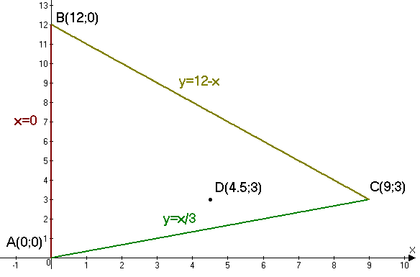
Теперь делаем проход по периметру АВС:
$$AB:x=0;y∈\left[0;12\right] \\ z=y^{2}-6y+90 \\ z_{y}^{'}=2y-6=0 \\ y=3$$
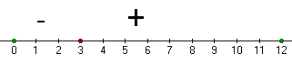
$$z\left(0\right)=90 \\ z\left(3\right)=9-18+90=81(min) \\ z(12)=144-72+90=162(max)$$

$$BC:y=12-x;x∈\left[0;9\right] \\ z=4x^{2}+{\left(12-x\right)}^{2}-36x-6\left(12-x\right)+90 \\ z_{x}^{'}=8x-2\left(12-x\right)-36+6=8x-24+2x-36+6=10x-54=0 \\ x=5.4$$
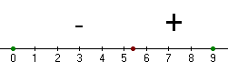
$$z\left(0\right)=144-72+90=162 \\ z\left(5.4\right)=4*{\left(5.4\right)}^{2}+{\left(12-5.4\right)}^{2}-36*5.4-6\left(12-5.4\right)+90=16.2\left(min\right) \\ z\left(9\right)=4*9^{2}+{\left(12-9\right)}^{2}-36*9-6\left(12-9\right)+90=81$$

$$AC:y=\frac{x}{3};x∈\left[0;9\right] \\ z=4x^{2}+{\left(\frac{x}{3}\right)}^{2}-38x+90 \\ z_{x}^{'}=8x+\frac{2x}{9}-38=0 \\ 74x=342 \\ x=\frac{342}{74}=\frac{171}{37}=4\frac{23}{37}$$
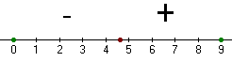
$$z\left(0\right)=90\left(max\right) \\ z\left(4\frac{23}{37}\right)=4*{\left(\frac{171}{37}\right)}^{2}+{\left(\frac{171}{111}\right)}^{2}-38*\frac{171}{37}+90= \\ =\frac{4*29241}{1369}+\frac{29241}{12321}-\frac{38*171}{37}+90=-87\frac{30}{37}+90=2\frac{7}{37}\left(min\right) \\ z\left(9\right)=4*9^{2}+{\left(\frac{9}{3}\right)}^{2}-38*9+90=81$$

Получаем:
$$z_{min}=z\left(4.5;3\right)=0 \\ z_{max}=z\left(0;12\right)=162$$

