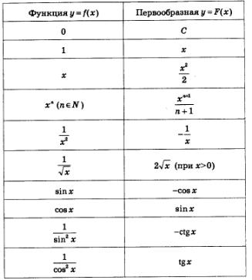
Воспользуемся таблицей первообразных
- ${2x}^{2}=2\int{x^{2}}dx=\frac{{2x}^{3}}{3}$
- $x^{2}-4x+5=\int{x^{2}}dx-4\int{xdx+5\int{1dx=\frac{x^{3}}{3}}}-4\int{xdx+5\int{1dx=\frac{x^{3}}{x}}}-4*\frac{x^{2}}{2}+5x=\frac{x^{3}}{3}-2x^{2}+5x$
- $8x-x^{2}=8\int{xdx-\int{x^{2}}}=4x^{2}-\frac{x^{3}}{3}$
- $\frac{3}{x}+2=3\int{\frac{1}{x}}dx+2\int{1dx=3\log\left(x\right)+2x}$
- ${\left(\frac{2}{x}\right)}^{2}$=$\frac{4}{x^{2}}dx=4\int{\frac{1}{x^{2}}}dx=-\frac{4}{x}$

