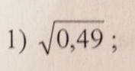 = 0,7
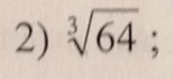 =4

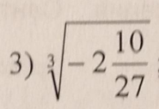 = $\sqrt[3]{\frac{64}{27}}=\sqrt[3]{\frac{4^{3}}{3^{3}}}=\frac{4}{3}$
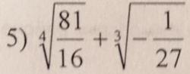=$\frac{3}{2}-\frac{1}{3}=\frac{9-3}{6}=\frac{7}{6}$
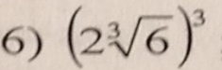 =2*6=12

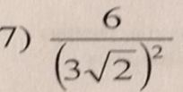 =$\frac{6}{9*2}=\frac{1}{3}$

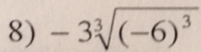=-3*(-6)=18
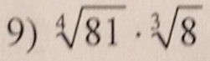=3*2=6
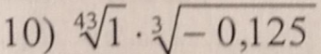 = 1*(-0,5)= -0,5
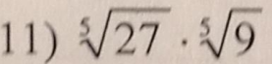 =$\sqrt[5]{27*9}=\sqrt[5]{3^{3}*3^{2}}=3$
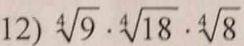=$\sqrt[4]{9*18*8}=\sqrt[4]{9*9*2*8}=3*2=6$
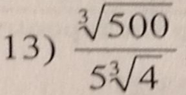 =$\frac{1}{5}*\sqrt[3]{\frac{500}{4}}=\frac{1}{5}*\sqrt[3]{125}=\frac{1}{5}*\sqrt[3]{5^{3}}=\frac{1}{5}*5=1$

$\frac{sin216}{sin72}-\frac{cos216}{cos72}=$ 2

Используем формулы
$\sin{3α} = 3\sin{α}–4\sin^{3}{α }$
$cos 3α = 4\cos^{3} α –3cos α$

$\frac{sin3*72}{sin72}=\frac{3sin72-4\sin^{3}{72}}{sin72}=3-4\sin^{2}{72}$

$\frac{cos⁡(3*72)}{cos72}=\frac{4cos^{3}72-3cos72}{cos72}=4\cos^{2}72-3$

$3-4\sin^{2}{72}-\left(4\cos^{2}72-3\right)=3-4\sin^{2}{72-4\cos^{2}{72+3=6-4(\sin^{2}{72+\cos^{2}{72)=}} }}$

= 6 – 4 = 2
Тема: Похідна
Знайти похідну:
- у=2х
- у=12х
- у=45х
- у=-7х
- у=-34х
- у=-123х
- у=56х+6
- у=78-1,3х
- у=х²
- у=х³
- у=х²⁵
- у=х¹⁴⁶
- у=х⁻⁶
- у=х⁻¹¹
- у=х⁻⁸⁹
- 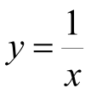
- 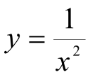
- 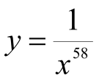
- 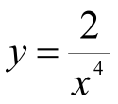
- 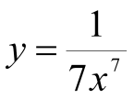
- 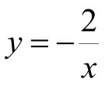
- 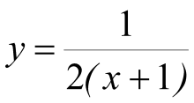
- 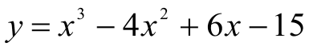
- 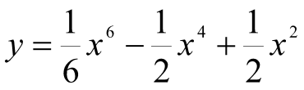
- 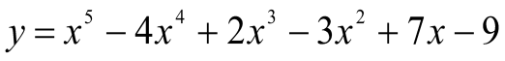
- 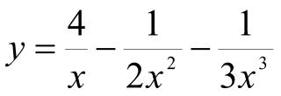
- 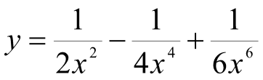
- 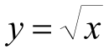
- 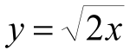
- 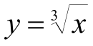
- 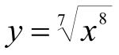
- 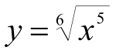
- 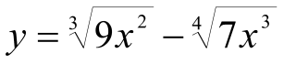
- 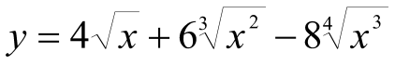
- 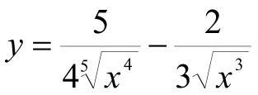
- 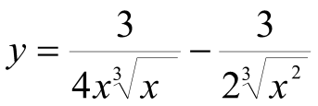
- у=е^{2х}
- у=е^{6х-2}
- у=cos2x
- y=sin(x+1)
- y=tg(x-4)
- y=ctg(x²)
- y=cos(x²-3x+7)
- y=sin(5x+x⁵-8)
- y=e^{x}lnx
- y=xlog₂(x+1)
- 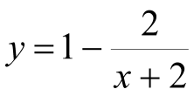
- 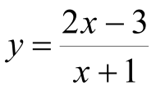
- 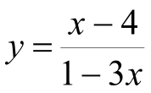
- 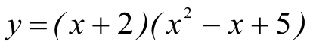
- 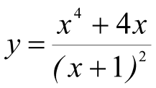
- 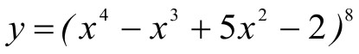
- 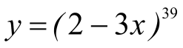
- 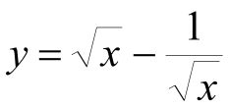
- 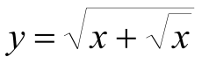
- 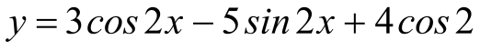
- 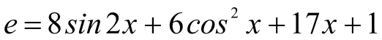
- 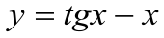
59.