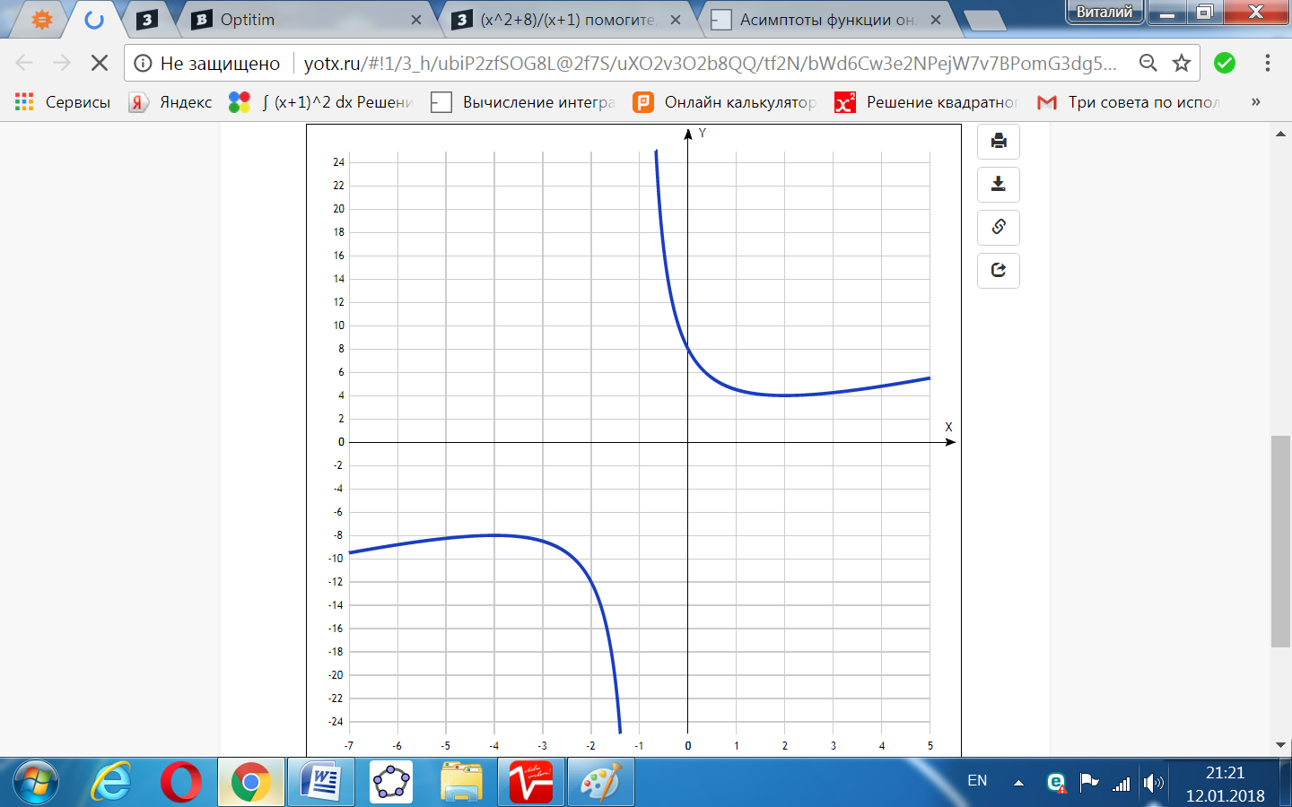

[Таблица точек](javascript:void(0);)

|  |  |
| --- | --- |
| **x** | **y** |
| -7 | -9.5 |
| -6 | -8.8 |
| -5 | -8.2 |
| -4 | -8 |
| -3 | -8.5 |
| -2 | -12 |
| -1 | - |
| 0 | 8 |
| 1 | 4.5 |
| 2 | 4 |
| 3 | 4.3 |
| 4 | 4.8 |
| 5 | 5.5 |

