Тест по английскому языку 6 класс

1. Fill in the missing letters of the words and you’ll have Santa’s wish for you.
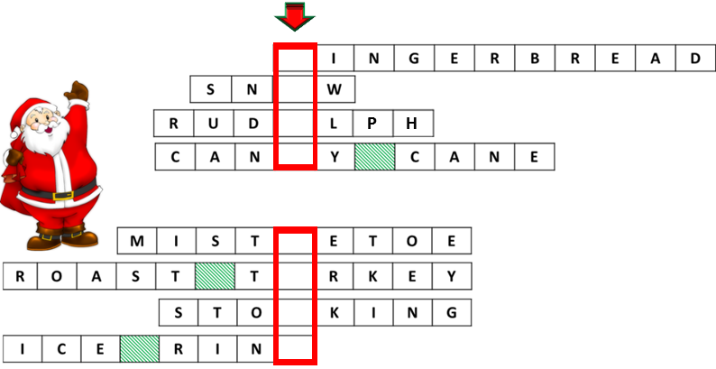

А) good life Б) good news В) good luck Г) good health

2. Mark whether the nouns are countable or uncountable.
1. advice a) countable b) uncountable
2. word a) countable b) uncountable
3. money a) countable b) uncountable
4. homework a) countable b) uncountable
5. news a) countable b) uncountable
А) 1b, 2b, 3a, 4a, 5a Б) 1b, 2a, 3b, 4b, 5a
В) 1a, 2a, 3b, 4b, 5a Г) 1b, 2a, 3b, 4b, 5b

3. Match the two halves of the tag question.
1.You were at the party yesterday, | a) hadn’t they?
2.They had a fantastic day, | b) didn’t he?
3. Oleg helped his grandfather, | c) didn’t we?
4. Nick makes his bed in the morning, | d) weren’t you?
5. Last winter we went to the mountains, | e) doesn’t he?
А) 1d, 2a, 3b, 4e, 5c Б) 1b, 2a, 3c, 4d, 5e
В) 1c, 2b, 3d, 4e, 5a Г) 1b, 2a, 3c, 4e, 5d

4. Choose the correct variant.
1. I haven`t packed ___ .
a) something b) anything c) nothing
2. He likes to get up early ___ the morning.
a) in b) at c) –
3. The ___ country in the world is Russia.
a) big b) bigger c) biggest
4. Which of the suitcases is ___?
a) you b) your c) yours
5. He speaks English ___.
a) good b) well c) goodly
А) 1b, 2a, 3a, 4c, 5a Б) 1c, 2c, 3a, 4b, 5a
В) 1b, 2a, 3c, 4c, 5b Г) 1c, 2b, 3b, 4b, 5a

5. Read the jumbled up conversation. Put it in the correct order.
1. Did you like it?
2. Last Sunday.
3. Yes, I did. It was fantastic.
4. When did you go to the zoo?
5. With my parents.
6. Who did you go there with?
А) 6, 3, 1, 2, 5, 4 Б) 1, 3, 6, 5, 4, 2
В) 4, 2, 1, 3, 5, 6 Г) 4, 2, 6, 5, 1, 3

6. Fill in the question words.
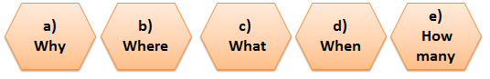
1. _____ did your mum make? - A cake.
2. _______ do you play jokes? - On April 1st.
3. _______ do you like parties? - Because they are fun.
4. ________ presents did you get? - Four.
5. _______ do you celebrate New Year? - At home.
А) 1e, 2d, 3b, 4c, 5a Б) 1c, 2d, 3a, 4e, 5b
В) 1b, 2a, 3c, 4e, 5d Г) 1c, 2d, 3e, 4b, 5a

7. Read the letter. Put the verbs in brackets into the correct tense form.
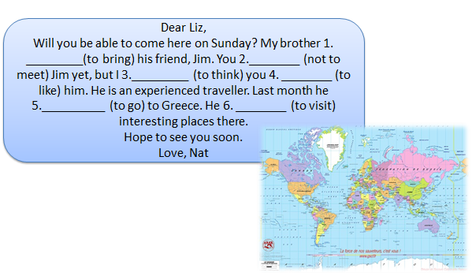
А) 1 will bring, 2 didn’t meet, 3 think, 4 will like, 5 went, 6. visited
Б) 1 is bringing, 2 haven’t met,3 think, 4 will like, 5 went, 6. visited
В) 1 brought, 2 haven’t met,3 think, 4 like, 5 has gone, 6. visited
Г) 1 brings, 2 didn’t meet, 3 will think, 4 liked, 5 went, 6. Visited

8. Solve the riddle.
It is a word of five letters. Take away two letters and you have only one left. What is it?
А) stone Б) one
В) aloud Г) mouth

9. Make up the sentence from the given words.
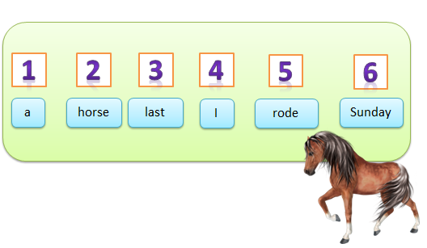
А) 6, 3, 1, 2, 5, 4 Б) 4, 5, 1, 2, 3, 6
В) 4, 2, 1, 3, 5, 6 Г) 4, 2, 6, 5, 1, 3

10. Find the mistake.
You wasn’t at home yesterday.
1 2 3 4
А) 1 Б) 2 В) 3 Г) 4

