https://znanija.com/task/24325749 y=12x/(9+x^2)

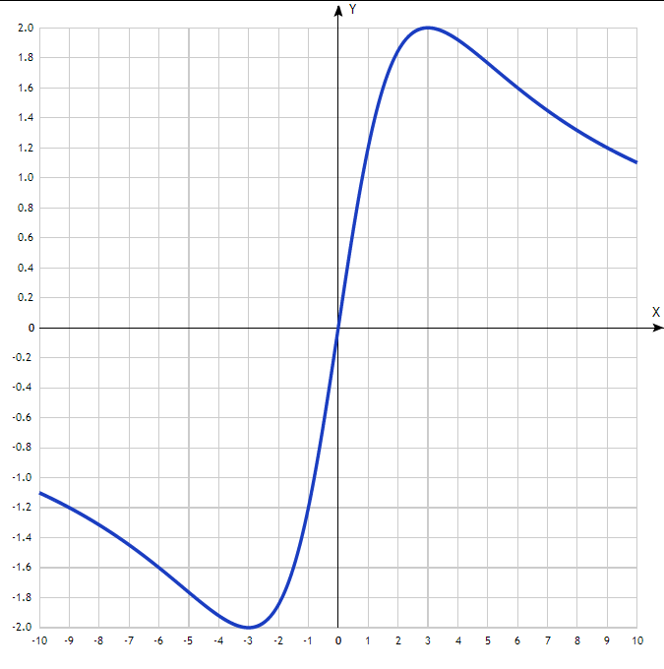
Таблица точек

x | y
-10 | -1.1
-9 | -1.2
-8 | -1.32
-7 | -1.45
-6 | -1.6
-5 | -1.76
-4 | -1.92
-3 | -2
-2 | -1.85
-1 | -1.2
0 | 0
1 | 1.2
2 | 1.85
3 | 2
4 | 1.92
5 | 1.76
6 | 1.6
7 | 1.45
8 | 1.32
9 | 1.2
10 | 1.1

