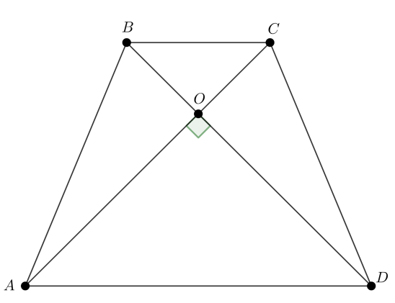
Дано: ABCD-трапеция, AC=9, BD=12, BC=4, AD=11.
Найти: $S_{ABCD}$
$$Решение: ABCD-трапеция⇒∆AOD\sim ∆BOC⇒\frac{BO}{DO}=\frac{CO}{AO}=\frac{BC}{AD}=\frac{4}{11}$$
$$CO=4x; AO=11x; BO=4y;DO=11y$$
$$\left\{\begin{aligned}AO+CO=AC \\ DO+BO=BD\end{aligned}\right.⇒\left\{\begin{aligned}11x+4x=9 \\ 11y+4y=12\end{aligned}\right.⇒\left\{\begin{aligned}x=\frac{3}{5} \\ y=\frac{4}{5}\end{aligned}\right.⇒\left\{\begin{aligned}AO=\frac{3}{5}AD \\ DO=\frac{4}{5}AD\end{aligned}\right.$$
$${AO}^{2}+{DO}^{2}={\left(\frac{3}{5}AD\right)}^{2}+{\left(\frac{4}{5}AD\right)}^{2}={AD}^{2}⇒∠AOD=90°$$
$$S_{ABCD}=0,5AC∙BD=0,5∙9∙12=54$$

