**Вариант 12**

**Упражнение 1**

*Вставьте* ***артикль****, где необходимо.*

1. He never eats ... meat, he always eats ... vegetables, ... cereals, ... seeds, ... fruit, and ... nuts. 2.He is ... ve­getarian. 3. This is ... pineapple. ... pineapple is delicious. 4. Elaine, ... apples are good for you!

**Упражнение 2**

*Вставьте* ***артикль****, где необходимо.*

1. There is ... jar of ... orange ... marmelade in ... middle of ... shelf. 2. There is ... big ... box of ... cereal to ... right of you. 3. There is ... bunch of ... bananas on ... table. Don't keep them in ... re­frigerator. 4. There is ... loaf of ... white ... bread on ... upper ... shelf of ... refrigerator. If you want your ... bread to be fresh, keep it only in ... refrigerator.

**Упражнение 3**

*Образуйте* ***сравнительную и превосходную сте­пень следующих прилагательных****. Не забудьте упо­треблять определенный артикль перед превосходной степенью прилагательных.*

* Hot
* long
* short
* clever
* silly
* great
* red
* black
* white

**Упражнение 4**

*Вставьте* ***предлоги on, in или into.***

1. Where is the book? — It is ... the table. 2. Where is the tea? — It is ... the cup. 3. Put the plates ... the table. 4. Put the book ... the bag. 5. There is a beautiful picture ... the wall.

**Упражнение 5**

*Вставьте* ***глагол to be в Present Simple.***

1.I ... a pupil. 2. My father ... not a teacher, he ... a scientist. 3. ... your aunt a doctor? — Yes, she .... 4. ... they at home? — No, they ... not at home, they ... at work. 5. My brother ... a worker. He ... at work.

**Упражнение 6**

Раскройте скобки, употребляя **глаголы в Future Simple.**

1. I want to get a medical checkup. I (to go) to my doctor tomorrow. 2. He (to give) me a complete examination. 3. The nurse (to lead) me into one of the examination rooms. 4. I (to take) off my clothes and (to put) on a hospital gown. 5. Dr. Setton (to come) in, (to shake) my hand, and (to say) "hello".

**Упражнение 7**

*Раскройте скобки, употребляя* ***глаголы в Present Continuous.***

(NOW) 6. Who (to fix) your sink? 7. What she (to do) now? — She (to dance). 8. The children (to brush) their teeth. 9. What he (do) at the moment? — He (to fix) his bicycle. 10. They (to have) a big dinner together.

**Упражнение 8**

*Переведите на английский, употребляя* ***глаголы в Present, Past или Future Simple Passive.***

Мне рассказали — Мне рассказывают — Мне расскажут

Мне показали — Мне показывают — Мне по­кажут

**Упражнение 9**

*Раскройте скобки, выбирая* ***требующееся время глагола.***

1. My friend asked me who (is playing, was play­ing) the piano in the sitting room. 2. He said he (will come, would come) to the station to see me off. 3. I was sure he (posted, had posted) the letter. 4. I think the weather (will be, would be) fine next week. I hope it (will not change, would not change) for the worse. 5. I knew that he (is, was) a very clev­er man.

**Упражнение 10-перевести**

**Nutritional value**

We should pay attention to food ingredients and food’s nutritional value. Nutritional value is the information about the energy (in calories), carbohydrates, proteins, fats, vitamins and minerals contained in a product. Analysis of this information helps to make the best choice of food for a healthy diet.

**Fast food**

Nowadays fast food restaurants open everywhere – from big megalopolises to small towns. They have their advantages and disadvantages. On the one hand, McDonalds, KFC and Subway help us save our money and time, but, on the other hand, they don’t offer us healthy meals. Hamburgers, cheeseburgers, fries, muffins and milk cocktails are tasty, but not very good for our health and figure.

**Healthy diet**

If we want to live long, we should pay attention to what we eat. A healthy diet usually includes a lot of fruit and vegetables, regular portions of fish or white meat, grains, nuts and a few liters of water per day. It is better to choose products without artificial ingredients and with minimal quantity of sugar.

**Упражнение 11**

**Перевести рецепт мороженого**

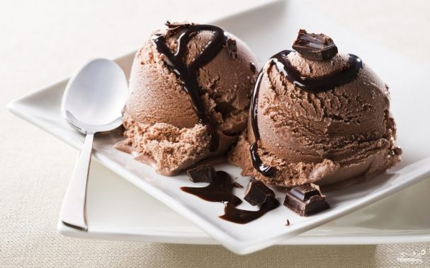

**INGREDIENTS**

* 50g dark chocolate
* 3 glasses milk
* 4 egg yolks
* 200g sugar

[

|  |  |
| --- | --- |
| http://www.interactive-english.ru/imagesforsite/recepti/icecream/1.jpg | If you like home-made delicacies, then this classic home-made chocolate ice cream is exactly what you are looking for.    [Перевод] |
| http://www.interactive-english.ru/imagesforsite/recepti/icecream/2.jpg | Bring milk to the boil and add grated chocolate. Take the mixture off the heat and cool down a little.    [Перевод] |
| http://www.interactive-english.ru/imagesforsite/recepti/icecream/3.jpg | Whisk egg yolks together with sugar. We will need to add them to the chocolate mixture.    [Перевод] |
| http://www.interactive-english.ru/imagesforsite/recepti/icecream/4.jpg | Put the mixture back on the hob and boil until thickening. Stir it constantly to avoid coagulation of eggs.    [Перевод] |
| http://www.interactive-english.ru/imagesforsite/recepti/icecream/5.jpg | Run with your finger over the spoon. If traces are left that means that the consistency is right.    [Перевод] |
| http://www.interactive-english.ru/imagesforsite/recepti/icecream/6.jpg | Pour the mixture into the moulds and put them into the freezer for 2 hours. We used plastic cups.    [Перевод] |
| http://www.interactive-english.ru/imagesforsite/recepti/icecream/7.jpg | Use cups as moulds or serve your ice cream like this. You can pour some syrup over ice cream. |

**Упражнение 12**

Написать **рецепт сырников** на английском, используя (написав) все ингредиенты.