Grammar
1. Choose the correct answers.
1 The telephone rang while I a shower.
a had b was having c were having
2 When you last night, I was reading a book.
a phoned b was phoning c were phoning
3 We saw Henry while we for the bus.
a waited b was waiting c were waiting
4 We were having dinner when Helen .
a came b was coming c were coming
5 While Bill and Kate their homework, their mother called them.
a did b was doing c were doing

2. Complete the sentences with the correct form of going to and the verbs in the box.
buy call not / cook not / walk take visit
1. I some photos tomorrow. 2 Maria her grandparents next week.
3. Tim dinner tonight. 4. Tom and Jim to school tomorrow.
5. We a new computer. 6. They me tonight.

___/6 marks
3 Complete the questions and answers with going to and the verbs in the box.
buy do go have invite (x2) watch
1 A What (you) tomorrow?
B I shopping.
2 A (we) the DVD tonight?
B Yes, .
3 A Who (she) to the party?
B She David.
4 A (he) a new sports car?
B No, .
5 A (they) a baby?
B No, .

___/10 marks

4. Complete the sentences with should or shouldn’t.
1 It’s hot. They open the window.
2 You watch TV all night.
3 He brush his teeth twice a day.
4 You call your parents. They’re worried.
5 We be late for school.

___/5 marks

5. Complete the sentences with must or mustn’t.
1 You use your mobile phone in the classroom.
2 I give the dog some water. He’s thirsty.
3 Stop it! You be rude to people.
4 I go home now. It’s late.
5 They drop litter.

___/5 marks
Vocabulary
1 Look at the pictures and complete the sentences with the words in the box.
clean cut damage plant pollute protect recycle reuse save throw turn waste

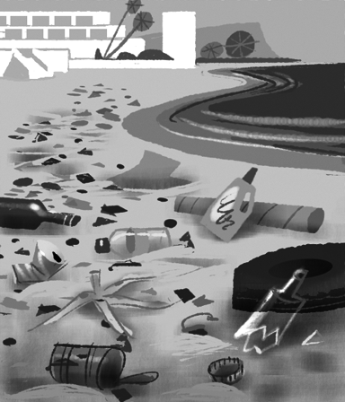  1 Let’s the beach up.  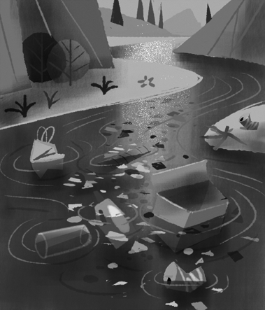  3 Don’t the rivers!  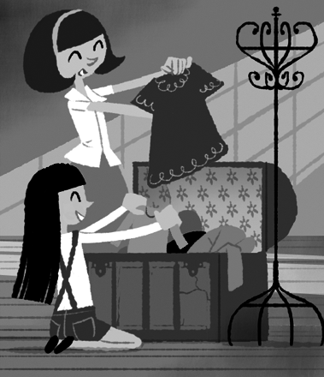  5 We should old clothes  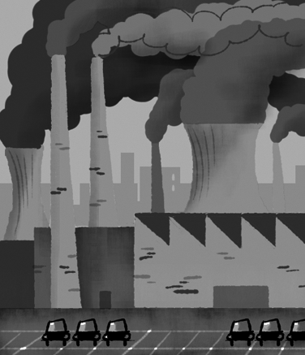  7 Don’t the environment.  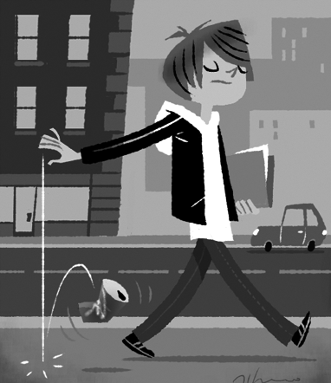  9 Don’t the can away! | 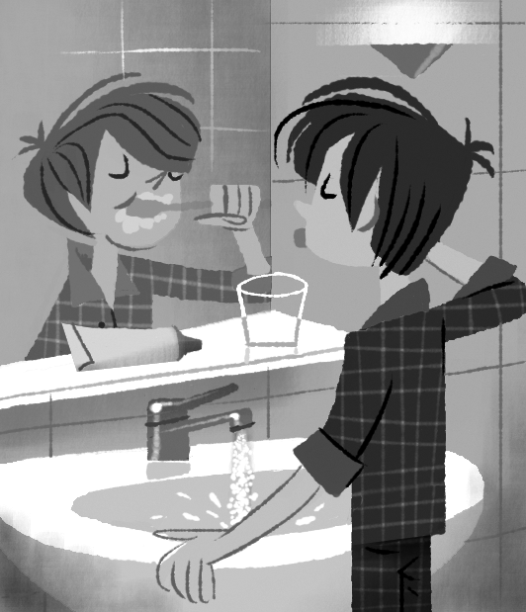  2 Don’t all that water!  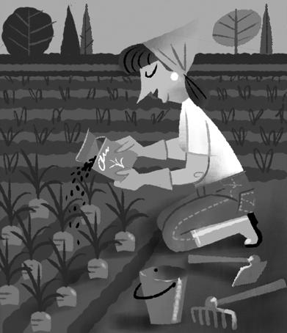  4 Let’s some vegetables.  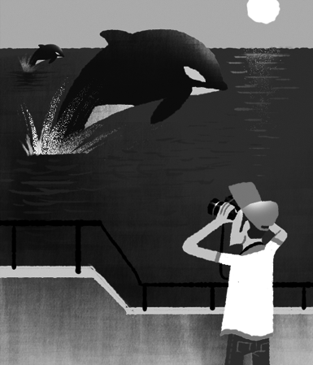  6 the whale!  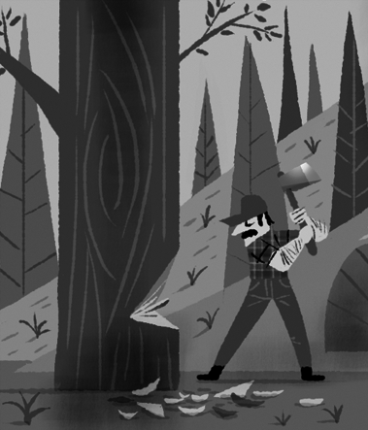  8 Don’t those trees down!  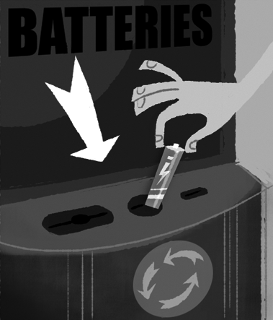  10 those things.

2 Complete the sentences with the words in the box.
away down off plant save up
1 Please help me clean the kitchen before Mum comes home.
2 We must these beautiful animals. They are in danger.
3 Why did they cut all the trees ?
4 I must some flowers in the garden this spring.
5 Please turn the TV when you leave the room.
6 Please don’t throw those books . Give them to your school library.
___/6 marks

3 Complete the sentences with words for materials or containers.
1 Don’t throw the p bags in the bin.
2 The fruit is on the w table.
3 There is a b of water over there.
4 Is there honey in the g jar?
5 I want a c of milk from the supermarket.
6 The sugar is in a m can.

___/6 marks

Speaking
1 Complete the dialogue with the words in the box.
any awesome cheap expensive help how much it’s sure take thanks
Shop assistant Good morning. Can I ¹ you?
Claire Yes, please. Have you got ² nice
T-shirts?
Shop assistant ³ . We’ve got lots. These are from India.
Claire ⁴ ! I like them all!
⁵ is this blue
T-shirt?
Shop assistant ⁶ 25€.
Claire That’s ⁷ . I don’t want it, ⁸ .
Shop assistant Those T-shirts are cheaper. The white
T-shirt is 5€.
Claire That’s ⁹ . I’ll
¹⁰ it.

___/10 marks

Total: ___/60 marks

