$$y=x^{3}; y=x+1$$
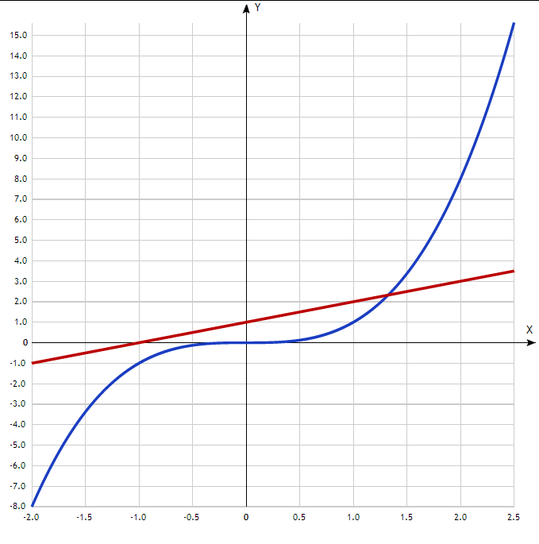

$$y=x^{3}; y=2x$$
