https://znanija.com/task/24109620
$$y=x^{2}-4x+3$$
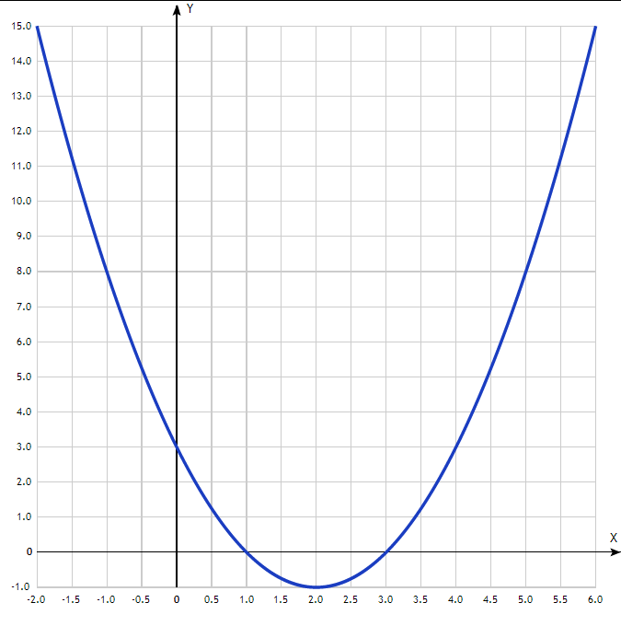
Таблица точек

x | y
-2.0 | 15
-1.5 | 11.25
-1.0 | 8
-0.5 | 5.25
0 | 3
0.5 | 1.25
1.0 | 0
1.5 | -0.75
2.0 | -1
2.5 | -0.75
3.0 | 0
3.5 | 1.25
4.0 | 3
4.5 | 5.25
5.0 | 8
5.5 | 11.25
6.0 | 15

