*y*(*x*)=1/*x*

|  |  |
| --- | --- |
| **x** | **y** |
| -5.0 | -0.2 |
| -4.5 | -0.22 |
| -4.0 | -0.25 |
| -3.5 | -0.29 |
| -3.0 | -0.33 |
| -2.5 | -0.4 |
| -2.0 | -0.5 |
| -1.5 | -0.67 |
| -1.0 | -1 |
| -0.5 | -2 |
| 0 | - |
| 0.5 | 2 |
| 1.0 | 1 |
| 1.5 | 0.67 |
| 2.0 | 0.5 |
| 2.5 | 0.4 |
| 3.0 | 0.33 |
| 3.5 | 0.29 |
| 4.0 | 0.25 |
| 4.5 | 0.22 |
| 5.0 | 0.2 |

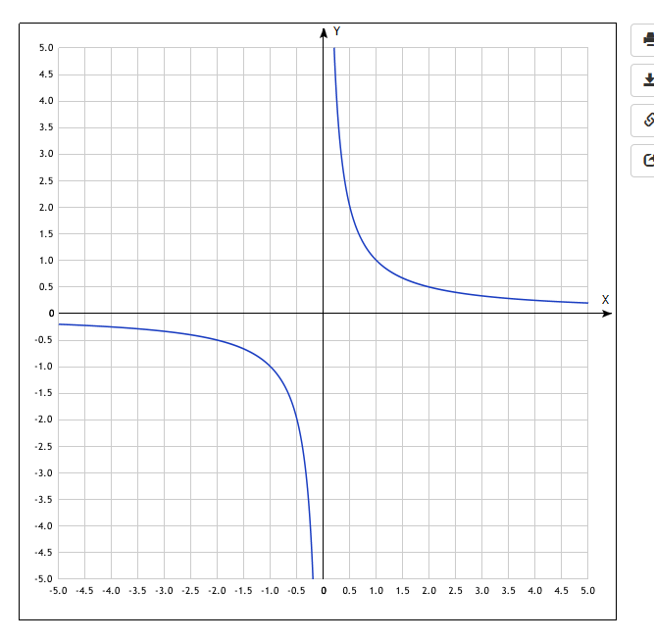

*y*(*x*)=2+1/*x*

|  |  |
| --- | --- |
| **x** | **y** |
| -5.0 | 1.8 |
| -4.5 | 1.78 |
| -4.0 | 1.75 |
| -3.5 | 1.71 |
| -3.0 | 1.67 |
| -2.5 | 1.6 |
| -2.0 | 1.5 |
| -1.5 | 1.33 |
| -1.0 | 1 |
| -0.5 | 0 |
| 0 | - |
| 0.5 | 4 |
| 1.0 | 3 |
| 1.5 | 2.67 |
| 2.0 | 2.5 |
| 2.5 | 2.4 |
| 3.0 | 2.33 |
| 3.5 | 2.29 |
| 4.0 | 2.25 |
| 4.5 | 2.22 |
| 5.0 | 2.2 |

yotx.ru Вконтакте![Наша группа Вконтакте - присоед](http://vk.com/club11624870)

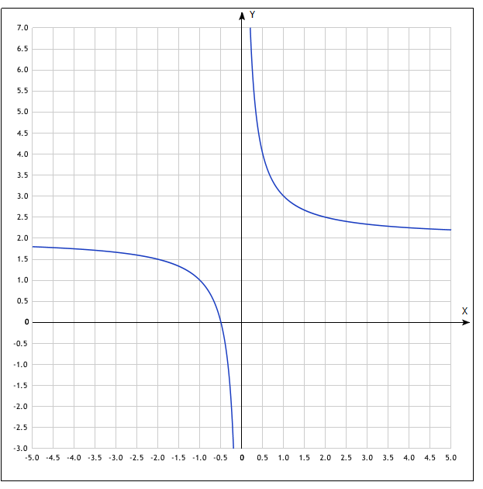

*y*(*x*)=−3+1/*x*

|  |  |
| --- | --- |
| **x** | **y** |
| -5.0 | -3.2 |
| -4.5 | -3.22 |
| -4.0 | -3.25 |
| -3.5 | -3.29 |
| -3.0 | -3.33 |
| -2.5 | -3.4 |
| -2.0 | -3.5 |
| -1.5 | -3.67 |
| -1.0 | -4 |
| -0.5 | -5 |
| 0 | - |
| 0.5 | -1 |
| 1.0 | -2 |
| 1.5 | -2.33 |
| 2.0 | -2.5 |
| 2.5 | -2.6 |
| 3.0 | -2.67 |
| 3.5 | -2.71 |
| 4.0 | -2.75 |
| 4.5 | -2.78 |
| 5.0 | -2.8 |

