Итоговая контрольная работа по английскому языку 7 класс

№1.READING
Read the text and answer the questions. You can give the short answers.
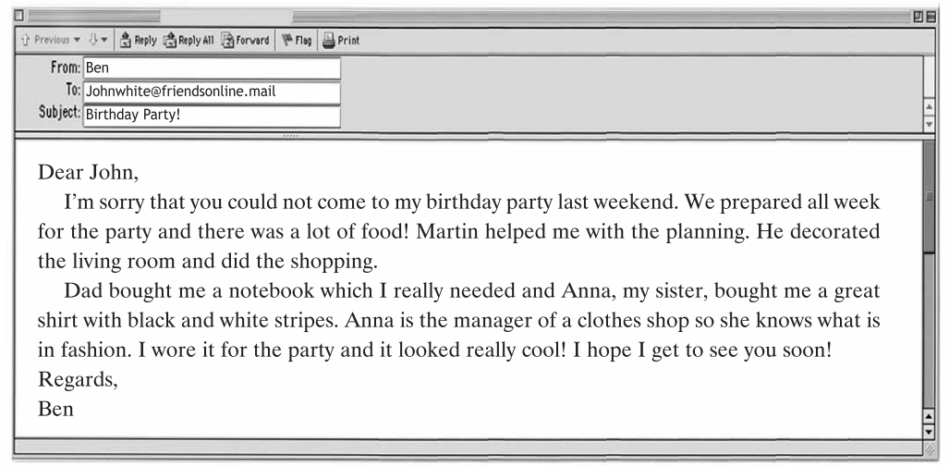

6)Who is Ben sending an e-mail to? ⎯To ________________________.
7)How long did Ben and Martin prepare for the party? --__________________.
8)How did Martin help? ⎯He _______________________.
9)What presents did Ben get? --________________and ________________.
10)What is Anna’s job? ⎯ She is a(n) _______________________.

№2. Choose the correct item.
11.Look at that little girl! She … fall over the box on the ground.  a) is going to b) will c) are  12.Tina is not here. She … out with her friends.  a) goes b) has been c) has gone  13.There are … of oranges in the fridge.  a) a lot b) any c) some  14.I only drink low-… milk when I’m on a diet.  a) butter b) fat c) salt  15.Can I have … water, please?  a) some b) a few c) no  16.He can’t do his homework … . Can you help him?  a) myself b) herself c) himself  17.My mum’s hair is … and curly. It’s really nice!  a) middle-aged b) shoulder-length c) slim  18. Sam is … of spiders.  a) scary b) scaring c) scared  19.Peter is more talented … Tim.  a) as b) than c) from  20.This is the shop … we bought the laptop.  a) why b) when c) where  21.He … in the countryside.  a) lives b) leaves c) live | 22.That was the … film I have ever seen.  a) most funny b) funnier  c) funniest  23.Lucas went to the … to buy some cough (кашель) syrup.  a) sports shop b) optician’s c) chemist’s  24.Young children shouldn’t … too much time in front of the TV.  a) get b) spend c) take  25.There is … traffic in the morning.  a) heavy b) slim c) thin  26.He has lived here … childhood.  a) on b) since c) for  27.Peter was watching a documentary when the phone …  a) rings b) rang c) have rang  28.Unfortunately, a lot of animals are in …  a) deserts b) danger c) waste  29. If he… (do) his homework, he will go to the cinema.  a) will do b) do c) does  30. I saw a … that was very funny.  a) thriller b) romance c) comedy

