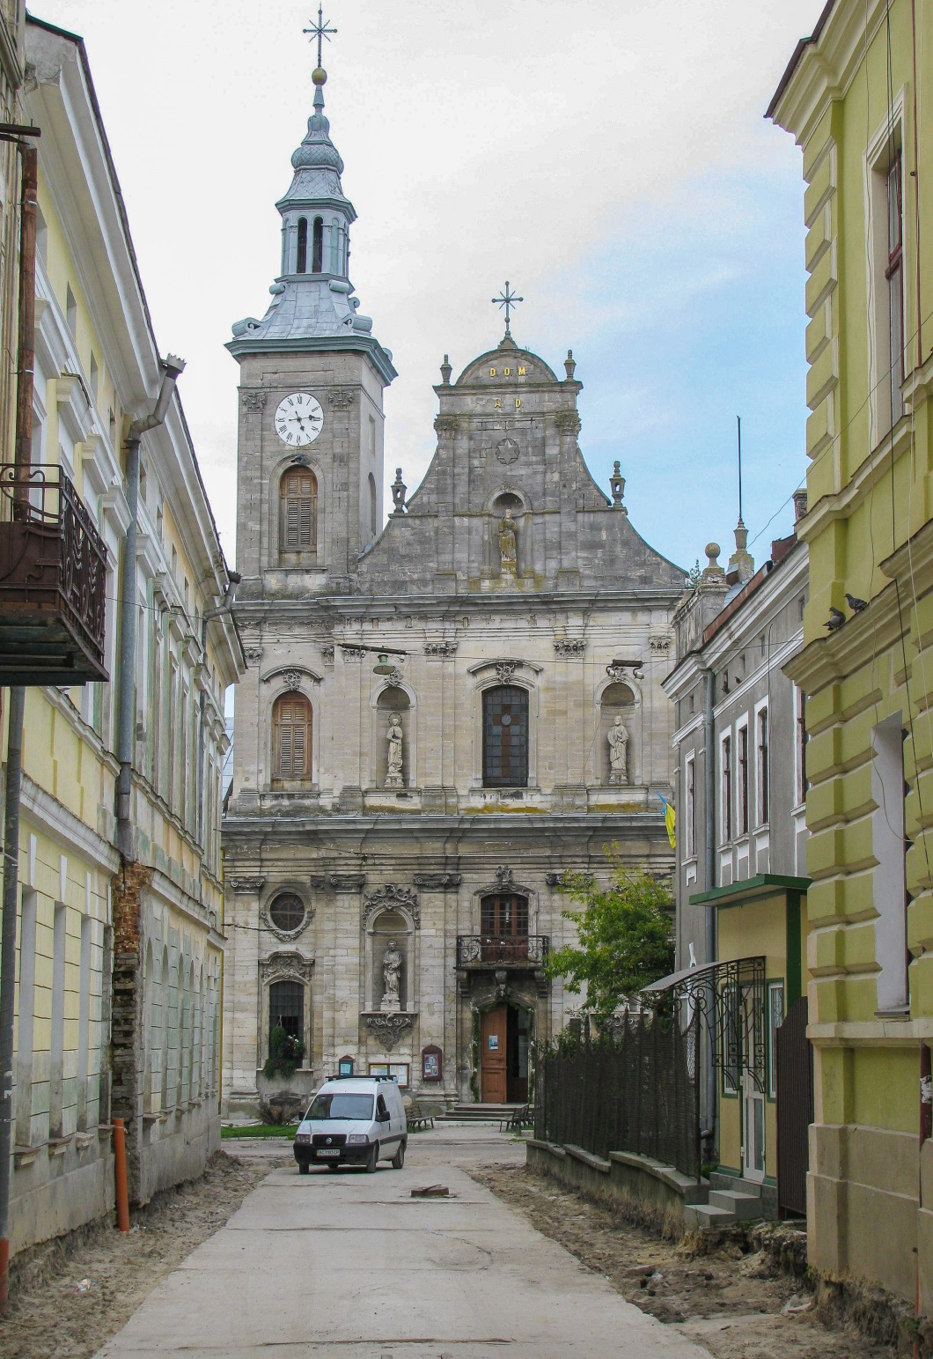

**Zolochiv**

Zolochiv is a city of district significance of Zolochiv district of Lviv region. This is the district center. It is located 64 km from Lviv on the Rava-Ruska-Ternopil highway. Its population is about 24 thousand inhabitants. The time of Zolochev's foundation and the origin of the name were lost in the centuries.

The first written mention of the city, found in archival documents recently in 1423. From 1427 the so-called Zolochiv yard remained in the city. This is the house of the owner of the city. From 1804 Zolochiv was part of the Austrian Empire.

Nowadays, the city is one of the few cities that boasts an ancient castle. The mighty defensive castle with Chinese and Grand Palaces is a unique architectural monument of the first half of the XVII century. Of the exotic attractions of the castle in Zolochev, it is worth noting the ritual of making a wish near the stones with encrypted inscriptions of the XV century. There is a lime alley planted in front of the Heroes of the Heavenly Hundred. This is a small beautiful green town.

**Welcome to us!**