http://www4f.wolframalpha.com/Calculate/MSP/MSP9821ih7cd5id15b287e0000248g9ii759i7b243?MSPStoreType=image/gif&s=54&w=70.&h=41.

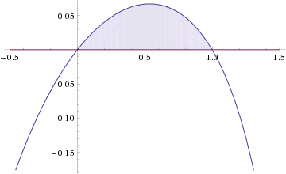

http://www4f.wolframalpha.com/Calculate/MSP/MSP4021ih7cdg11e2f86ea00001299ge6g869cedih?MSPStoreType=image/gif&s=54&w=118.&h=39.

http://www4f.wolframalpha.com/Calculate/MSP/MSP10031ih7cd5id15b287e00004f2c8agc50h1g152?MSPStoreType=image/gif&s=54&w=580.&h=22.

http://www4f.wolframalpha.com/Calculate/MSP/MSP10061ih7cd5id15b287e00003992b9i35ch7e1ie?MSPStoreType=image/gif&s=54&w=580.&h=22.

http://www4f.wolframalpha.com/Calculate/MSP/MSP10091ih7cd5id15b287e00002ie4ig1eh4c4df03?MSPStoreType=image/gif&s=54&w=580.&h=22.

http://www4f.wolframalpha.com/Calculate/MSP/MSP9971ih7cd5id15b287e000010iigbhc99fc4e13?MSPStoreType=image/gif&s=54&w=310.&h=36.&cdf=Resizeable

http://www4f.wolframalpha.com/Calculate/MSP/MSP15711ih7cbf16i8ee665000032d74d042d7fgid2?MSPStoreType=image/gif&s=54&w=61.&h=18. http://www4f.wolframalpha.com/Calculate/MSP/MSP15681ih7cbf16i8ee66500002hbhaf7hhdbb6h2h?MSPStoreType=image/gif&s=54&w=34.&h=18. http://www4f.wolframalpha.com/Calculate/MSP/MSP15651ih7cbf16i8ee66500005032d68a286dg4c0?MSPStoreType=image/gif&s=54&w=39.&h=18.