Unit of a long term plan  Module 8. Our neighborhood. |  |  | School:
Date:04.02.2021 |  |  | Teacher’s name: Seitova Zh.Zh
Class: 6 |  |  | Number present: |  | Number absent:
Lesson title |  |  | a/an-some/any/every/no and compounds P.90
Learning objectives(s) that this lesson is contributing to |  | 6.S1 provide basic information about themselves and others at sentence level on an increasing range of general topics  6.S5 recount basic story and events on a range of general and curricular topics  6.UE8 use a/an-some/any/every/no and compounds to talk about already decided plans on a limited range of familiar general and curricular topics  6.W1 plan, write, edit and proofread work at text level with support on a limited range of general and curricular topic
Lesson objectives |  | All learners will be able to:  - Identify the theme, new words and use them as the basis for discussion.  - Demonstrate knowledge for usage of the structures:. a/an-some/any/every/no. Transfer information from the given information into a graphic organizer.  Most learners will be able to:  - Select, compile, and synthesize information for an oral presentation  - Provide a point of view in conversations and discussions; speak about plans.  Some learners will be able to:  - Respond to and discuss the reading passage using interpretive, evaluative and creative thinking skills.  - Make a plan. Respond to and discuss the reading passage using interpretive, evaluative and creative thinking skills.
Value links |  | Cooperation, respect each other's opinion, functional literacy.
Crosscurricular links |  | Social Science, Psychology, Literature, Geography, Information Technology.
Previous learning |  | Talking about books.
Useof ICT |  | Smart board for showing a presentation, getting additional information, playing the audio files.
Intercultural awareness |  | Discuss the diversity of books and speak about writers in Kazakhstan, in the UK, in Russia.
Health and Safety |  | Breaks and physical activities used. Everyday classroom precautions will ensure that safety measures are provided to prevent the exposure of electrical power cords.
Planned timings | Planned activities |  |  | Resources
Theme: using a/an-some/any/every/no and compounds
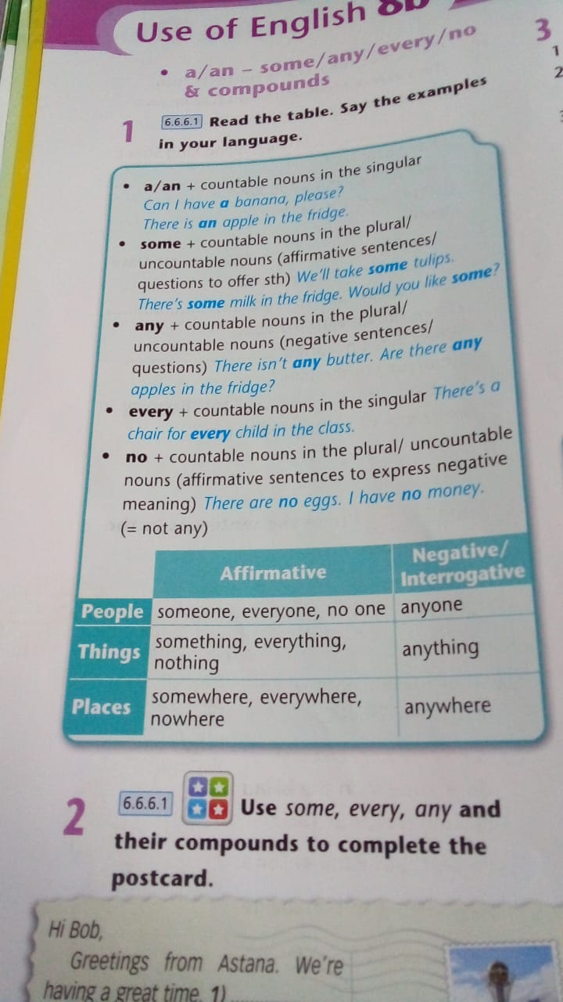
Task 1
Ex.2 P.90 Use some, every, any and their compounds to complete the postcards
Ending the lesson  6 min. | Students express their attitude to the lesson and give self-assessment using the method: “Six thinking hats”:  - Green: How can you use today's learning in different subjects?  - Red: How do you feel about your work today?  - White: What have you leant today?  - Black: What were the weaknesses of your work?  - Blue: How much progress have you made in this lesson? (Now I can, I still need to work on, I've improved in, Today I learnt... )  Yellow: What did you like about today's lesson?  Slide (Homework)  Slide "Six thinking hats"  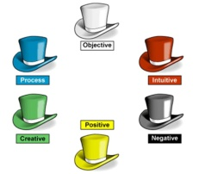
Differentiation –  how do you plan to give more support? How do you plan to challenge the more  able learners? |  |  | Assessment –  how are you planning to check learners’learning? |  |  | Critical thinking
Differentiation can be achieved through the selection of activities, identification of learning outcomes for a certain student, provision of individual support to learners, selection of learning materials and resources based on the individual abilities of learners. |  |  | Assessment criteria:  - Identify the main idea in extended talks with little support.  - Apply topic related vocabulary in speech appropriately arranging words and phrases into well-formed sentences.  - Demonstrate the ability to participate in a conversation.  Descriptor:  A learner:  - selects an appropriate answer.  - completes the task.  - uses appropriate subject-specific vocabulary while speaking.  - discusses questions and answers the questions within the group.  - Observation  - Feedback on the work  - Peer-assessment |  |  | Students think critically, exploring, developing, evaluating and making choices about their own and others’ ideas

