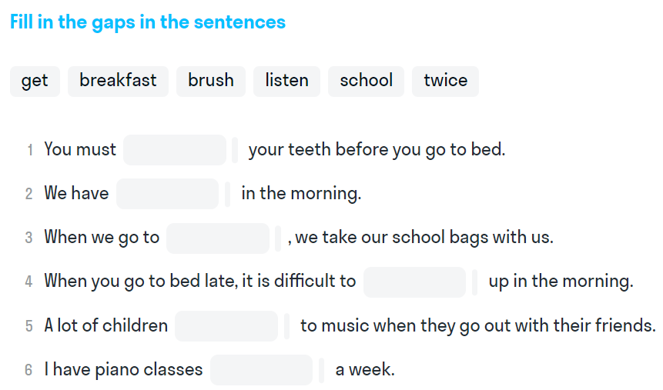
1.
2. Read the text and mark statements (True, False, Not Stated)
I'm a cat. My name is Sooty. I live with Cathy. I'm her pet. Let me tell you about my day.
I get up at 5 o'clock but I don't have breakfast then. Cathy gets up at 7 o'clock. She brushes her teeth and has a shower, and I wash my face. Then Cathy gives me cat food, and I have breakfast. Cathy has breakfast too, but she doesn't like cat food.
After breakfast, Cathy goes to work, and I go to bed. In the afternoon, Cathy comes home for lunch, and we have lunch together. I have cat food for lunch. Then I go to bed again.
When Cathy comes home in the evening, she plays with me. We usually play ball games. I can run after the ball and catch it. I often play with my toy mouse. Then we have dinner. I have cat food for dinner. After dinner, we watch TV, listen

- Sooty has breakfast at 5 o'clock.
- Sooty has cat food for breakfast.
- Cathy works at home.
- Sooty sleeps in the daytime.
- Sooty hasn't got any toys.
- Cathy's house is big.
- Sooty goes out for a walk on Saturdays and Sundays.

Present Simple
3. Put the given verbs in the correct forms
- Mike ___________(work) in the office from Monday to Friday.
- He ____________(fly) to France on holiday every summer.
- Clara _________(study) at university.
- My granny _______ (watch) TV at home every day.
- Mary often______( go) swimming in the ocean.
- Little baby Angel _______(cry) a lot.
- Mr Julian ________(live) far from town.

