**Name: Karolina**

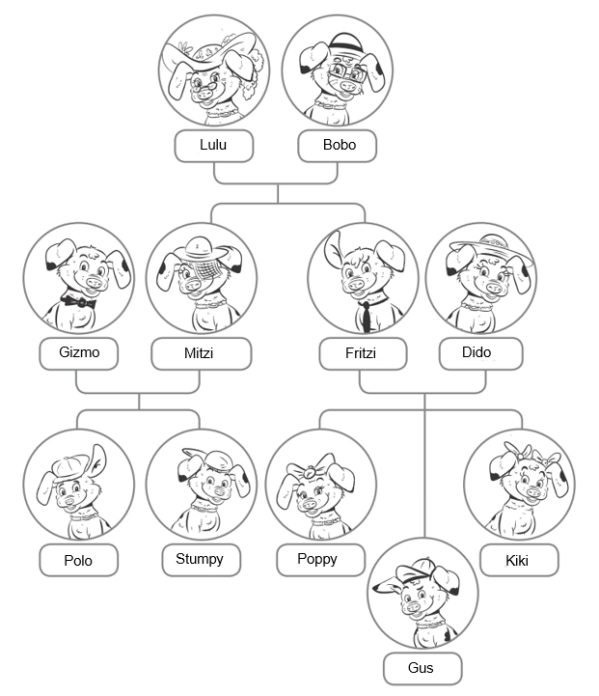

**Class: 5-A**

VOCABULARY

1 Look at the family tree and complete the sentences.

0 Lulu is Gus’s *grandmother*.

1 Mitzi is Poppy’s             aunt                  .

2 Gizmo is Kiki’s           uncle                    .

3 Polo is Stumpy’s        brother                       .

4 Mitzi is Bobo’s        daughter                       .

5 Gus is Dido’s              son                 .

6 Stumpy is Poppy’s      cousin                         .

7 Bobo is Kiki’s   granny                            .

8 Kikki is Poppy’s         sister                      .

/8

2 Complete the sentences with the words in the box. There is one extra word.

American at ~~China~~ on park Poland Polish school UK

Wu and Chen are from 0*China*. They’re Chinese. They’re in the 1                    .

Jane is British. She’s from the 2                    . She’s 3                     holiday.

Mark is from the USA. He’s 4                     . He’s at 5                    .

Dorota is from 6                    . She’s 7                      home.

/7

3 Circle the correct words.

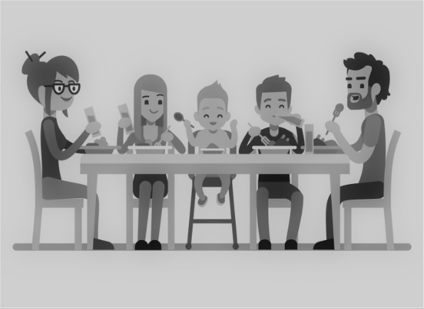

Look at this0*painting / photo*. It is 1*the / by* Hank Adams. He is an American 2 *artist / picture*. The 3*children / people* in the picture are Mr and Mrs Cole, Lola, Ollie and Jojo. It’s my favourite 4*picture / artist*!

/4

GRAMMAR

4 Complete the sentences. Write the correct positive [✓] or negative [✗] form of *to be*.

0 My best friend *isn’t* Spanish. **✗**

0 My best friend *is* from Poland. **✓**

1 I        isn’t              eleven years old. **✗**

2 We     are                 American. **✓**

3 You and your family      aren’t                British. **✗**

4 Enzo and Maria        are              Italian. **✓**

5 Luisa’s mum            isn’t          a teacher. **✗**

6 The man in the photo           is           my dad. **✓**

7 I      am                at Granny’s house.  **✓**

8 Paul and I    aren’t                  students. **✗**

/8

5 Complete the sentences with *my* or *your*.

0 I’m a student. *My* mum is a teacher.

1 It’s       your      birthday today. Happy birthday, Sue!

2 I’m Turkish.     My        parents are Turkish too.

3 You’re from the UK.     Your        nationality is British.

4 I’m here with    my         cousins.

/4

6 Look at the family tree in Exercise 1. Write sentences with possessive *’s.*

0 Fritzi dad *Bobo is Fritzi’s dad*.

1 Gus mum Dido is Gus’es mum

2 Stumpy brother Polo is Stumpy’s brother

3 Lulu daughter Mitzi is Lulu’s daugther

4 Polo parents Mitzi and Gizmo are Polo’s parents.

/4

COMMUNICATION

7 Match 1-5 to a-f to make a dialogue.

**Sam:** 0 *c*   
1   e

2   f

**Dad:** 3   b   

4    d

**Gordon:**5   a

**a** Nice to meet you, too, Mr Brown.

**b** Hello, Gordon.

**c** Dad, this is Gordon.

**d** Nice to meet you.

**e** He’s my classmate.

**f**  Gordon, this is my dad.

/5

Vocabulary / 19

Grammar / 16

Communication / 5

Your total score / 40